

dELHI EAST DISTRICT ROAD SAFETY REPORT



**Report by:**



**Data support by:**

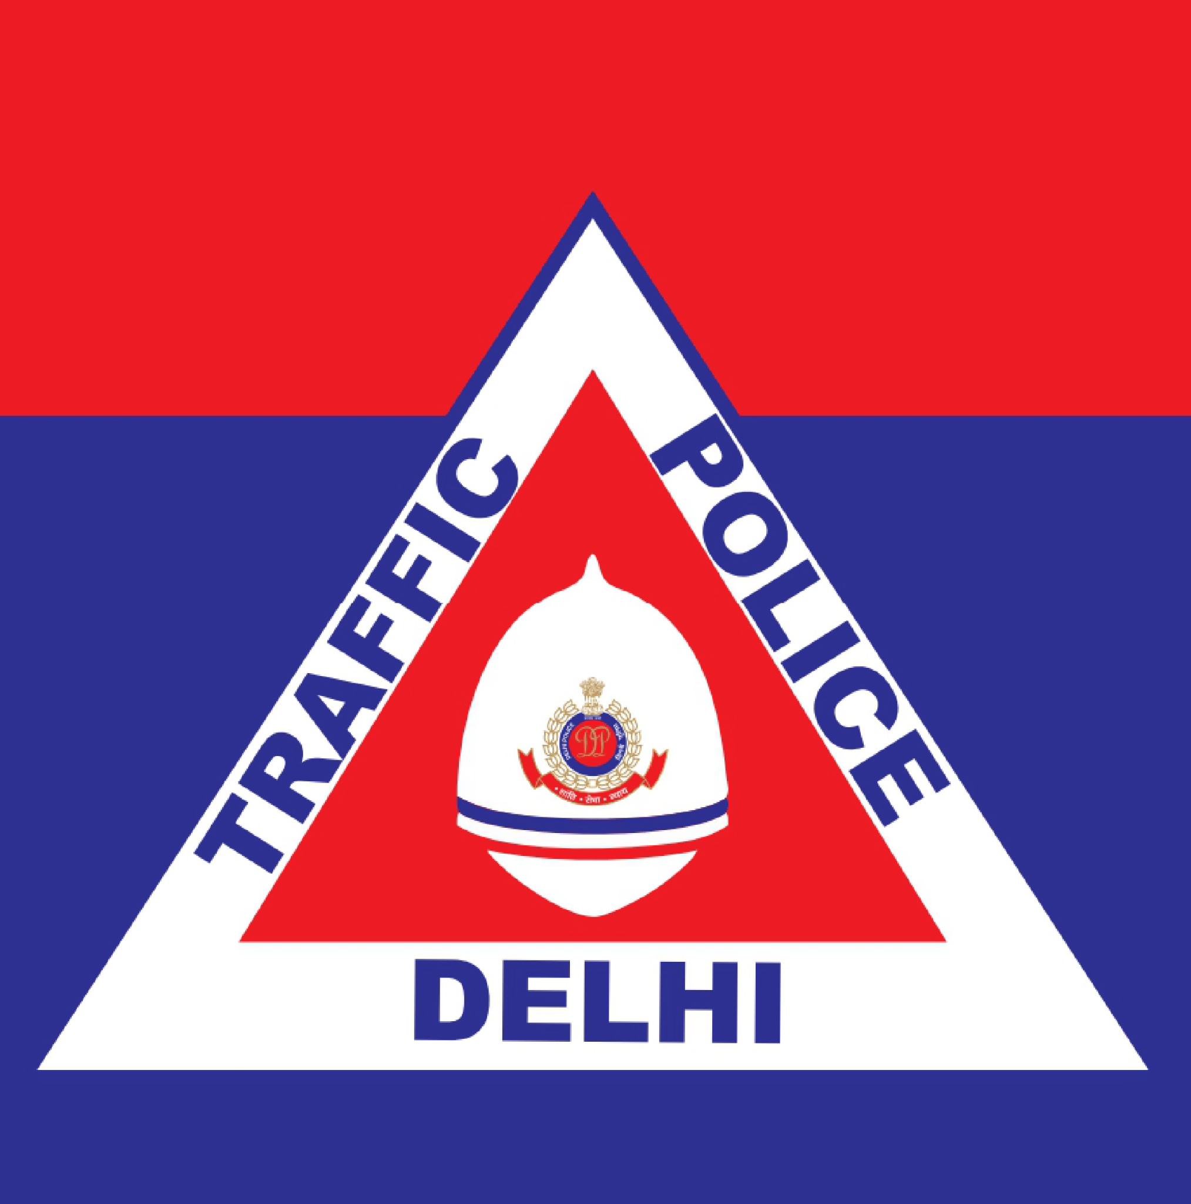

**Supported by:**







Table of Contents

List of Figures and Tables 5

List Of Abbreviations 6

Key Highlights 8

Introduction 9

Methodology 10

ABOUT THE DISTRICT 11

**A** **: Road safety situation and trends in East district** 12

A.1 : Road crash death trends 12

A.1.1 : Fatal road crashes and fatalities trend. 12

A.1.2 : Road crash fatalities by road user types. 13

A.1.3 : Road crash deaths by month 14

A.1.4 : Road crash deaths by time and day of week 15

A.2 : Road crash deaths by age and gender 16

A.2.1 : Road crash deaths by gender 16

A.2.2 : Road crash deaths by age-groups and gender 16

A.3 : Road crash deaths by road user type 17

A.3.1 : Total Road crash deaths by road user type (2019, 2021, 2022) 17

A.3.2 : Timewise Road crash deaths by Road user type 18

A.3.3 : Who-hit-whom matrix 19

A.4 : Hit-and-runs in fatal road crashes 20

A.4.1 : Percentage of hit-and-run and non-hit-and-run cases 20

A.4.2 : Hit-and-run Road user types 20

A.5 : Road Crash Heatmaps 21

A.5.1 : Heatmap of all road crash deaths 21

A.5.2 : Heatmap of all pedestrian deaths 21

A.5.3 : Heatmap of all motorcycle (rider + pillion) related deaths 22

A.6 : High Risk Locations 23

A.6.1 : List of high-risk locations 23

A.6.2 : Map of all high-risk locations 23

A.6.3 : High risk corridors 24

**B** **: Data to Action** 25

B.1 : Ghazipur Roundabout 25

B.1.1 : General Description of the site 25

B.1.2 : Existing Land Use 25

B.1.3 : Conflict Points 26

B.1.4 : Existing Scenario 26

B.1.5 : Issues Identified 27

B.1.6 : Proposed Design 29

B.1.7 : Summary budget estimates 30

B.2 : Hasanpur Depot 34

B.2.1 : General description of the site 34

B.2.2 : Existing Land Use 34

B.2.3 : Existing Scenario 35

B.2.4 : Issues identified 35

B.2.5 : Proposed Design 37

B.2.6 : Summary budget estimates 38

B.3 : Safe School Zone: Rajkiya Sarvodaya Bal Vidyalaya (RSBV), Shakarpur 42

B.3.1 : General description of the site 42

B.3.2 : Existing Scenario 43

B.3.3 : Issues identified 45

B.3.4 : Activity map 46

B.3.5 : Proposed design 48

B.3.6 : Summary budget estimates 50

# List of Figures and Tables

Figure 1: Fatal Road crashes and fatalities trend 12

Figure 2: Road crash fatalities by road user types 13

Figure 3: Average Road crash deaths by months 14

Figure 4: Road cash deaths by gender 16

Figure 5: Road crash deaths by age groups and gender 16

Figure 6: Road crash deaths by road user type (2019, 2021, 2022) 17

Figure 7: Timewise Road crash deaths by road user types 18

Figure 8: Percentage of hit-and-run and non-hit-and-run cases 20

Figure 9: Hit-and-run Road user types 20

Figure 10: Heatmap of all road crash deaths in East district 21

Figure 11: Heatmap of all pedestrian deaths due to road crashes in East District 21

Figure 12: Heatmap of all motorcycle related deaths due to road crashes in East District 22

Figure 13: Map of all high-risk locations intervened in East District 23

Figure 14; Vulnerable Road users on corridors 24

Figure 15: Vulnerable Road users’ death per km 24

Figure 16: Home to school modal distribution: Rajkiya Sarvodaya Bal Vidyalaya 43

Figure 17: School to home modal distribution: Rajkiya Sarvodaya Bal Vidyalaya 43

Table 1: Road crash deaths by time and day of week 15

Table 2: Who-hit-whom matrix 19

Table 3: List of high-risk locations 23

# List Of Abbreviations

* **GNCTD** Government of National Capital Territory of Delhi
* **DM** District Magistrate
* **DMRC** Delhi Metro Rail Corporation
* **DRSC** District Road Safety Committee
* **DTC** Delhi Transport Corporation
* **DTP** Delhi Traffic Police
* **FIR** First Information Report
* **FOB** Foot Over Bridge
* **GIS** Geographic Information System
* **GT** Grand Trunk
* **HV** Heavy Vehicle
* **IACP** International Association of Chiefs of Police
* **IIT** Indian Institute of Technology
* **IPC** Indian Penal Code
* **IRC** Indian Road Congress
* **iRAD** Integrated Road Accident Database
* **ISBT** Inter State Bus Terminal
* **KM** Kilometre
* **LMV** Light Motor Vehicle
* **MACT** Motor Accident Claims Tribunal
* **MCD** Municipal Corporation of Delhi
* **MoRTH** Ministry of Road Transport and Highways
* **MPD** Master Plan for Delhi
* **MTW** Motorised Two-Wheeler
* **NCR** National Capital Region
* **NCT** National Capital Territory
* **NGO** Non-Governmental Organisation
* **NH** National Highway
* **NHAI** National Highways Authority of India
* **NIC** National Informatics Centre
* **NSP** Netaji Subhash Place
* **PCR** Police Control Room
* **QGIS** Quantum Geographic Information System
* **RSLA** Road Safety Lead Agency
* **SKV** Sarvodaya Kanya Vidyalaya
* **SOP** Standard Operating Procedure
* **TRIPC** Transportation Research and Injury Prevention Centre
* **UT** Union Territory
* **WHO** World Health Organisation

# Key Highlights

* There is a sudden increase in fatal road crashes from 50 fatal road crashes to 79 fatal road crashes from 2021 to 2022 due to the mobility restrictions during 2021.
* Pedestrians and motorcyclists have been the most affected road users at 43.8% and 38.4% respectively.
* Sundays and Fridays of timeslots 2200 to 0200 have witnessed the most road fatalities.
* Most of the fatal road crashes were hit and runs amounting to 62.6% of the total crashes; of these 52% crashes had pedestrians as the victims.
* Motorcyclists were among the major victims of the fatal road crashes where they were hit primarily by cars and truck/tractor drivers.
* The high-risk locations of the East District are Ghazipur Chowk and Hasanpur Chowk.

# Introduction

There has been an increase of road crash fatalities in Delhi since the easing of pandemic mobility restrictions. Vulnerable road users such as pedestrians, two-wheeler occupants and three-wheeler occupants are most at risk of severe injuries and - in worst case scenarios - death in a road crash. This risk which hinders the basic right of mobility for the road users warrants that effective and evidence-based road safety interventions and programs must be implemented regularly and systematically to mitigate the effects of road crashes.

In the year 2023, the Transport Department released the ‘Data to Action’ report which analysed 2019 to 2021 data and identified high-risk locations for each of the eleven districts in Delhi. The report provided detailed maps, overall analysis for the National Capital Territory (NCT) of Delhi, and general recommendations for each district. The report was presented to the District Road Safety Committees (DRSCs) to guide them in implementing road safety interventions and address the most urgent road safety risk factors in their jurisdictions. The DRSCs take the lead in drafting the district road safety plan. They are instrumental in planning road safety interventions for high-risk locations in the district, implement interventions on the ground, and disburse road safety funds.

As a next logical step, to take evidence-based action in order to reduce crashes, the Transport Department are producing highly customised district specific road safety reports (DRSR) for the DRSCs. These reports include detailed findings on road crashes in the given district including a list of high-risk locations and provide specific recommendations to reduce crashes. The purpose of these DRSR is to guide DRSCs in implementing evidence-based interventions to reduce crash fatalities in high-risk locations and provide detailed infrastructure designs for specific locations which can be readily implemented on ground. The ultimate goal of this process is to inform and train the DRSC members in replicating the evidence-based action in the future.

# Methodology

Data Source

The District Road Safety Report (DRSRs) focused on road crash fatalities’ data in the National Capital Territory (NCT) of Delhi from the years 2019, 2021 and 2022. The data source for this report is police crash data records from the Motor Accident Claims Tribunal (MACT) cells of the Districts. In addition, this data is supplemented by the FIR lists from the Delhi Traffic Police. The dataset was compiled, digitised, and cleaned at the Transport Department.

Data Analysis

The digitised datasets were compiled and analysed using MS Access to produce descriptive statistics and were mapped using Quantum Geographic Information Systems (QGIS) platform, to identify high-risk locations including high-risk corridors in each district. Similar process will be followed for producing district road safety reports for the remaining districts.

On-site Investigation of High-risk Locations and Corridors

An in-depth and on-site investigation was conducted for the identified high-risk locations. At the site, both qualitative and quantitative data were collected which informed the design of the interventions. The data collection was based on the following parameters:

* Inspection of the road infrastructure and land use at the site.
* Identification of hazards and conflict points, especially pedestrians’ movement, bus stop locations.
* Assessment of the type and quality of enforcement
* Observations on road user behaviour, parked vehicles, street vendors and accessibility of vulnerable road users
* Identification of types of road users and traffic mix and speed.

These data points were collated and presented for the selected high-risk sites, and were used to inform the design of the proposed interventions.

Report Structure

Each district has a dedicated report. There will be a total of 11 reports - one for each district in NCT Delhi. The report is divided into three parts. The first part includes the introduction of road safety in the context of the district, and methodology that was followed to produce the report. The second part covers the discussion on the road safety situation in the given district. Finally, the last part of the report provides detailed investigation and recommendations for the selected high-risk sites in the district.

# ABOUT THE DISTRICT

The District of East, Delhi is located on the other side of River Yamuna i.e., Trans-Yamuna area. It is bounded by the border of Uttar Pradesh comprising of Noida and Ghaziabad. It has an elevation of 239 metres above sea level.

Area: 64sqkm

Villages and Panchayats: 6

Tehsils: 3

Subdivisions and blocks: 3

Constituencies: 3

Courts: 2

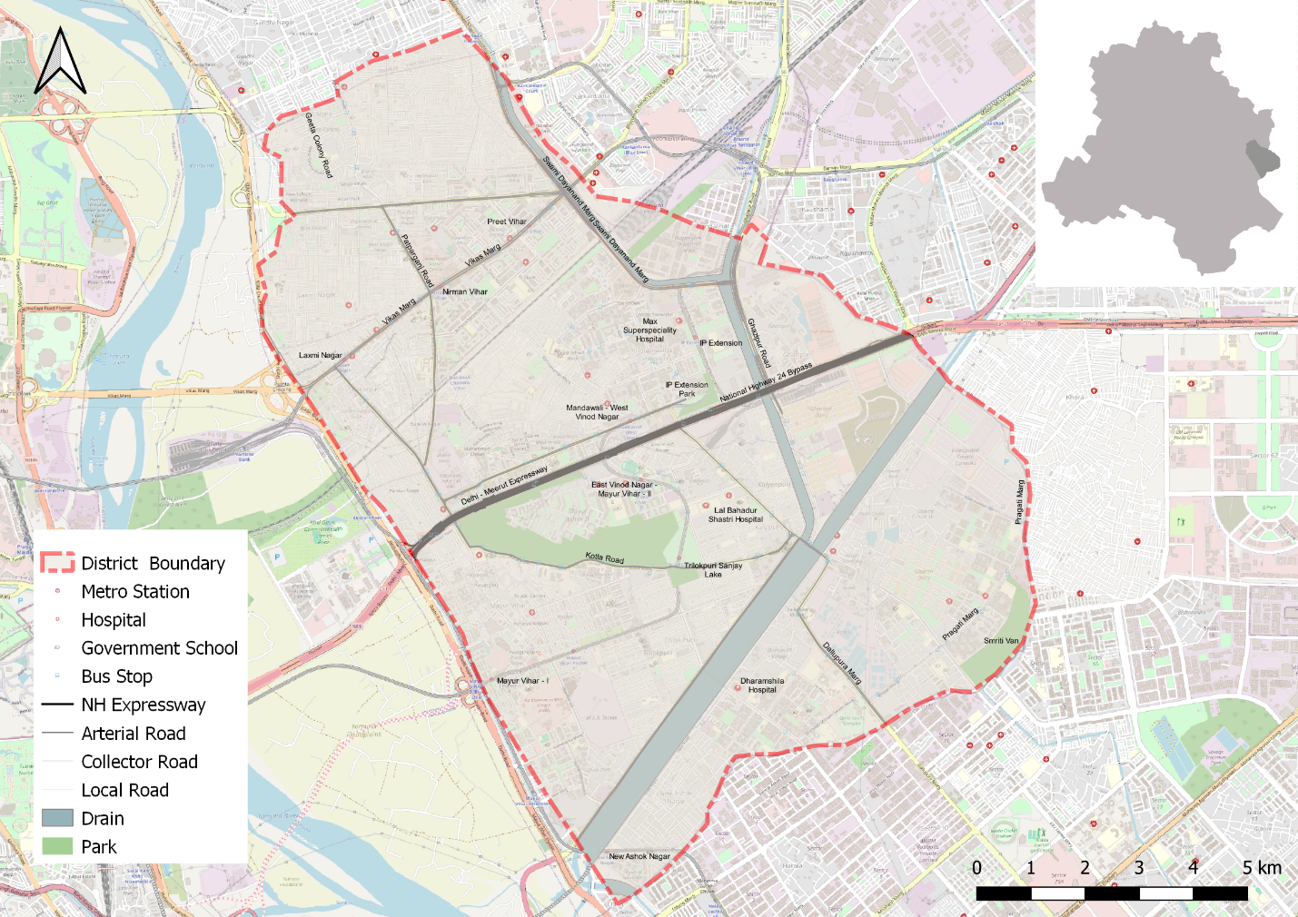

# **: Road safety situation and trends in East district**

## : Road crash death trends

### : Fatal road crashes and fatalities trend.

Figure : Fatal Road crashes and fatalities trend

There were 79 fatal road crashes in the East District of Delhi in 2022 with 80 persons killed in these crashes. There is a 44% increase compared to the previous year 2021 which is 50. One person is killed in road crashes in the East District every four to five days.

### : Road crash fatalities by road user types.

Figure : Road crash fatalities by road user types

Motorcyclists, auto rickshaw occupants and pedestrians formed a majority of persons killed in road crashes in the East District across all three years. Between the highlighted categories, the motorcyclist and autorickshaw occupants’ fatalities surpassed the pedestrian fatalities in 2021 and 2022.

### : Road crash deaths by month

Figure : Average Road crash deaths by months

January, March and August witnessed the highest number of persons killed followed by April and October, there is no discernible pattern of fatalities by month.

### : Road crash deaths by time and day of week

|  |  |  |  |  |  |  |  |  |
| --- | --- | --- | --- | --- | --- | --- | --- | --- |
|  | **Monday** | **Tuesday** | **Wednesday** | **Thursday** | **Friday** | **Saturday** | **Sunday** | **Total** |
| **02:00-06:00** | 4 | 2 | 2 | 1 | 3 | 2 | 5 | 19 |
| **06:00-10:00** | 2 | 7 | 4 | 5 | 4 | 3 | 4 | 29 |
| **10:00-14:00** | 4 | 7 | 1 | 2 | 5 | 5 | 2 | 26 |
| **14:00-18:00** | 7 | 2 | 4 | 2 | 5 | 2 | 2 | 24 |
| **18:00-22:00** | 3 | 7 | 7 | 7 | 7 | 8 | 7 | 46 |
| **22:00-02:00** | 8 | 3 | 7 | 3 | 12 | 9 | 16 | 58 |
| **Total** | 28 | 28 | 25 | 20 | 36 | 29 | 36 | 202 |

Table : Road crash deaths by time and day of week

Note: Data not available for one road crash deaths

Thirty percent of the total road crash deaths occurred at night 10:00 pm to 2:00 pm. Similarly, 38% of the total deaths occurred either on Saturdays or on Sundays.

## : Road crash deaths by age and gender

### : Road crash deaths by gender

Figure : Road cash deaths by gender

### : Road crash deaths by age-groups and gender

Figure : Road crash deaths by age groups and gender

Looking at the absolute numbers, the males had a higher number of fatalities 89% compared to females. Among the males, the fatalities were observed to be highest in the age group of 20-29 years , followed by 30-39 years.

## : Road crash deaths by road user type

### : Total Road crash deaths by road user type (2019, 2021, 2022)

Total fatalities:203

Figure : Road crash deaths by road user type (2019, 2021, 2022)

*Other includes cycle rickshaws, converted rickshaws and hand carts

Ninety percent of fatalities were among vulnerable road users (i.e., pedestrians, motorcyclists, cyclists, and auto rickshaw occupants). Among this, forty four percent of road crash deaths in the East district were among pedestrians, followed by motorcyclists (39%).

### : Timewise Road crash deaths by Road user type

Figure : Timewise Road crash deaths by road user types

*Other includes cycle rickshaws, converted rickshaws and hand carts

### : Who-hit-whom matrix

|  |  |  |  |  |  |  |  |  |  |
| --- | --- | --- | --- | --- | --- | --- | --- | --- | --- |
| **Victim Road User** | **Impacting Vehicle** | | | | | | | | |
| **Motorcycle** | **3-Wheeler** | **Car** | **Bus** | **Truck/ Tractor** | **Single Vehicle Crash** | **Other** | **Un-known** | **Total** |
| Pedestrian | 7 | 3 | 9 | 7 | 8 | 0 | 0 | 55 | 89 |
| Cyclist | 0 | 0 | 1 | 0 | 1 | 0 | 0 | 2 | 4 |
| Motorcyclist | 3 | 2 | 12 | 4 | 13 | 5 | 1 | 38 | 78 |
| 3-Wheeler Occupant | 0 | 1 | 6 | 1 | 0 | 2 | 0 | 5 | 15 |
| Car Occupant | 3 | 0 | 0 | 0 | 1 | 3 | 0 | 0 | 7 |
| Bus Occupant | 0 | 0 | 0 | 1 | 0 | 0 | 1 | 0 | 2 |
| Truck Occupant | 1 | 0 | 0 | 0 | 4 | 2 | 0 | 0 | 7 |
| Other | 1 | 0 | 0 | 0 | 0 | 0 | 0 | 0 | 1 |
| Total | 15 | 6 | 28 | 13 | 27 | 12 | 2 | 100 | 203 |

Table : Who-hit-whom matrix

Note: Other includes cycle rickshaws, converted rickshaws and hand carts

Among all fatal road crashes where the impacting vehicle was known, pedestrians and motorcyclists were found to be the most vulnerable category of road users. They were often hit by trucks and tractors. Hit-and-run crashes dominate both the categories of cases where the impacting vehicle was not known for 167 cases in case of pedestrians and 113 in case of motorcyclists.

## : Hit-and-runs in fatal road crashes

### : Percentage of hit-and-run and non-hit-and-run cases

Figure : Percentage of hit-and-run and non-hit-and-run cases

Overall, Three out of five crashes are hit-and-run cases. The high rate of hit-and-run cases is indicative of non-reporting of accused vehicles as well as non-reporting of crashes by the public.

### : Hit-and-run Road user types

Figure : Hit-and-run Road user types

## : Road Crash Heatmaps

### : Heatmap of all road crash deaths

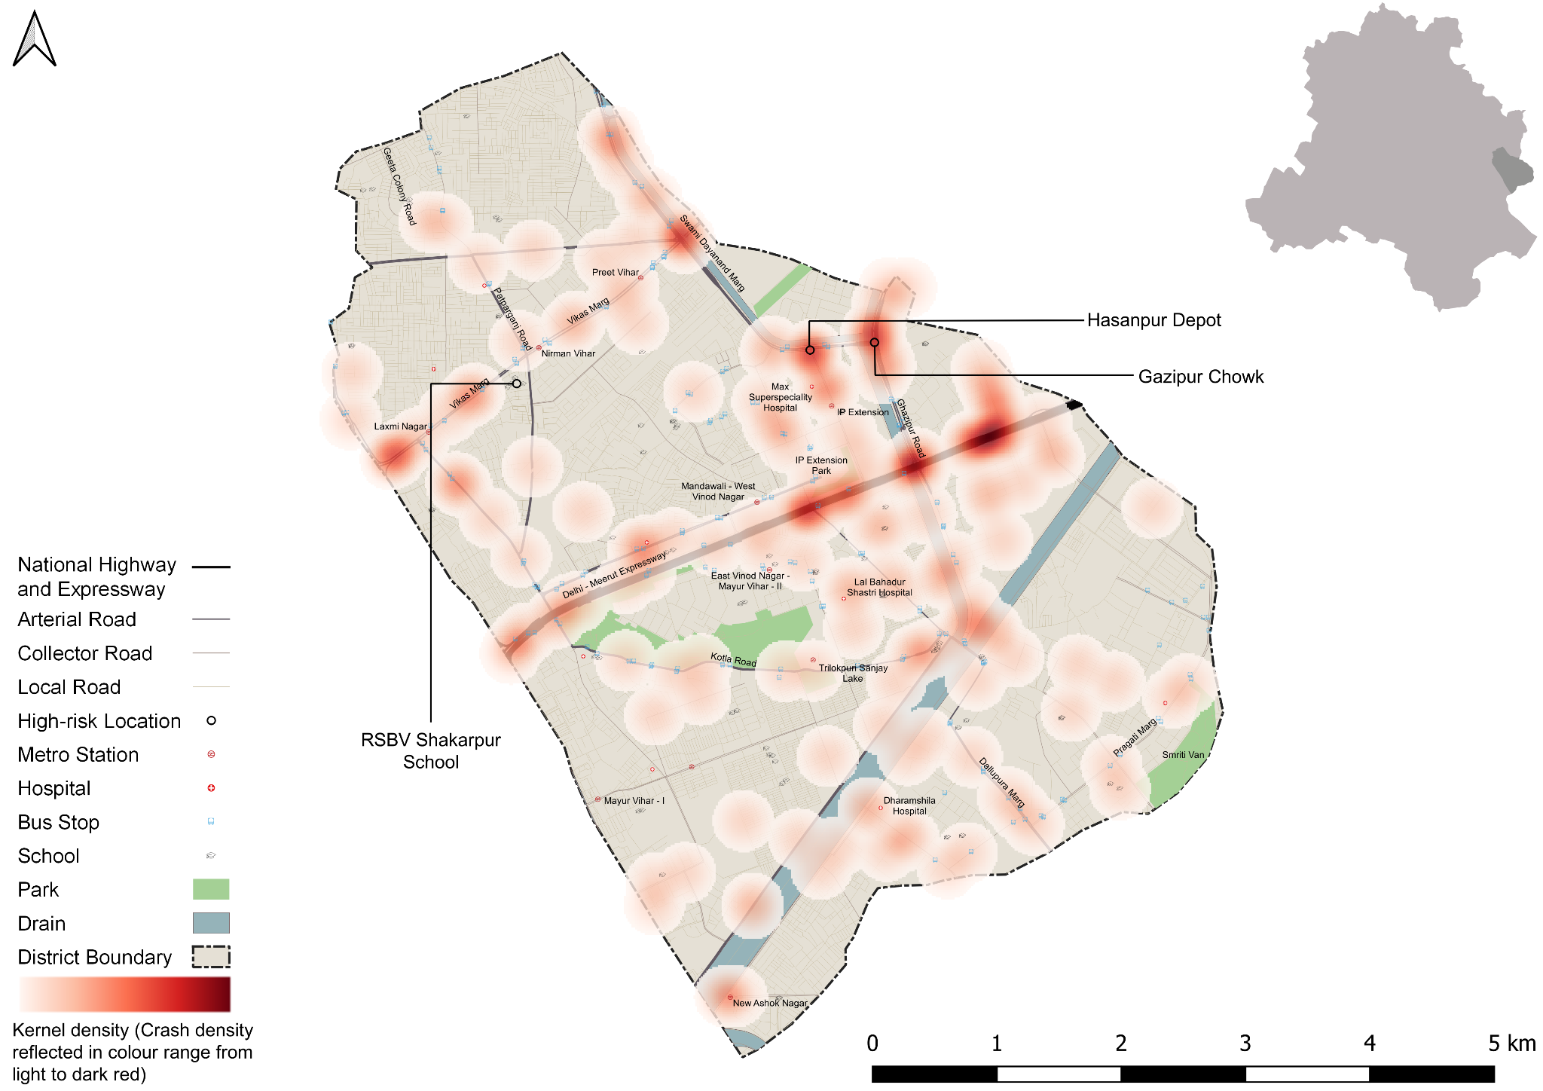

Figure : Heatmap of all road crash deaths in East district

### : Heatmap of all pedestrian deaths

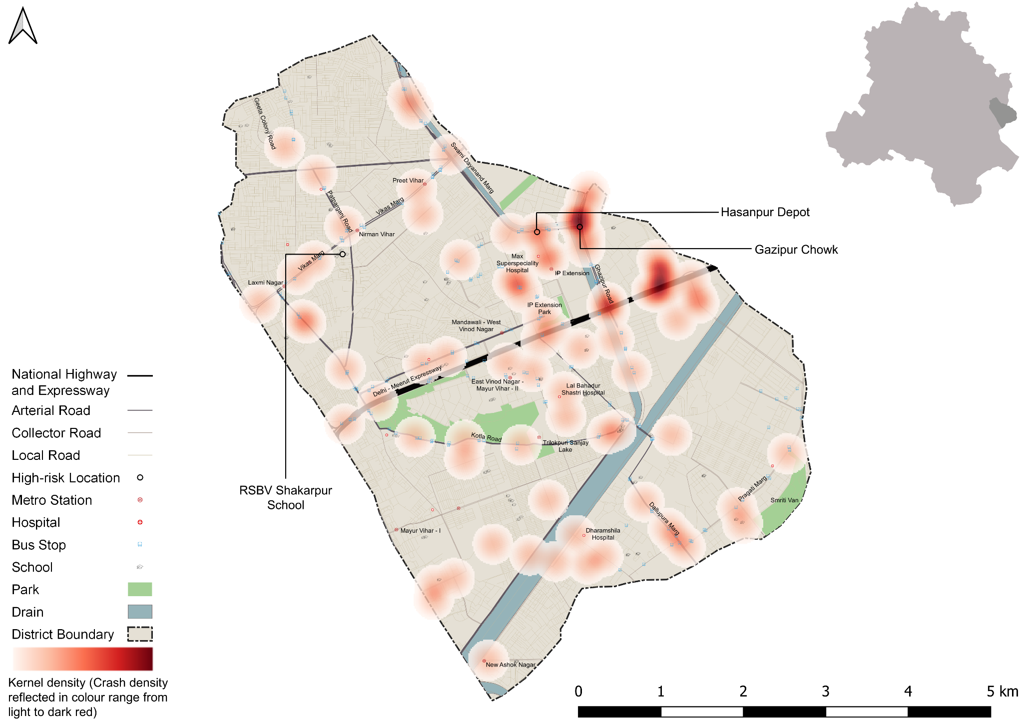

Figure : Heatmap of all pedestrian deaths due to road crashes in East District

### : Heatmap of all motorcycle (rider + pillion) related deaths

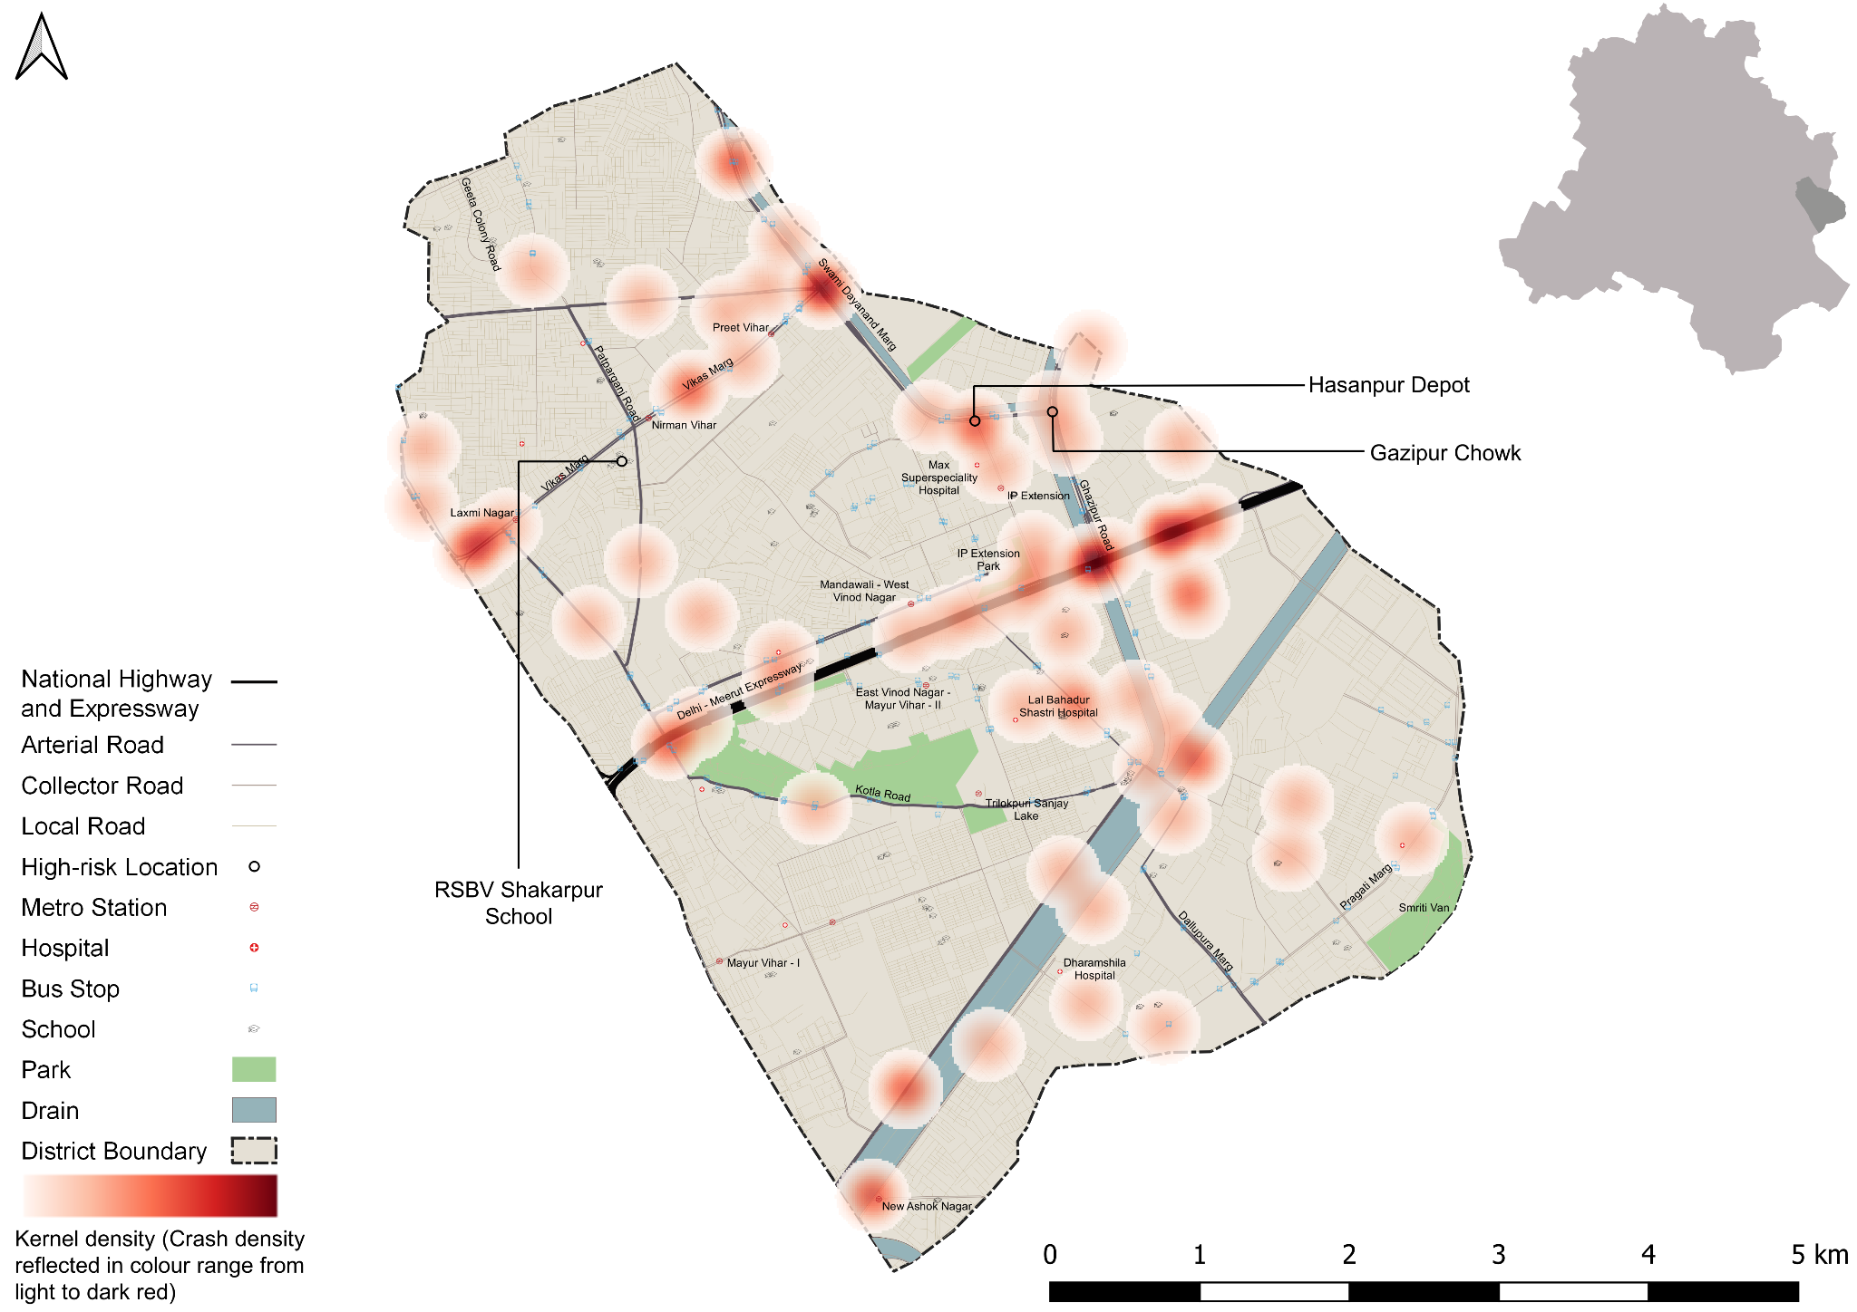

Figure : Heatmap of all motorcycle related deaths due to road crashes in East District

## : High Risk Locations

### : List of high-risk locations

The following is a list of high-risk locations in the East district which includes the number of fatal crashes, hit-and-run crashes, and deaths occurred during these crashes in years 2019, 2021 and 2022.

|  |  |  |  |
| --- | --- | --- | --- |
| **High Risk Location** | **Total fatal crashes** | **Total hit and run fatal crashes** | **Total persons killed** |
| Gazipur Chowk | 5 | 4 | 5 |
| Hasanpur Chowk | 5 | 4 | 5 |
| RSKV Shakarpur | 0 | 0 | 0 |

Table : List of high-risk locations

### : Map of all high-risk locations

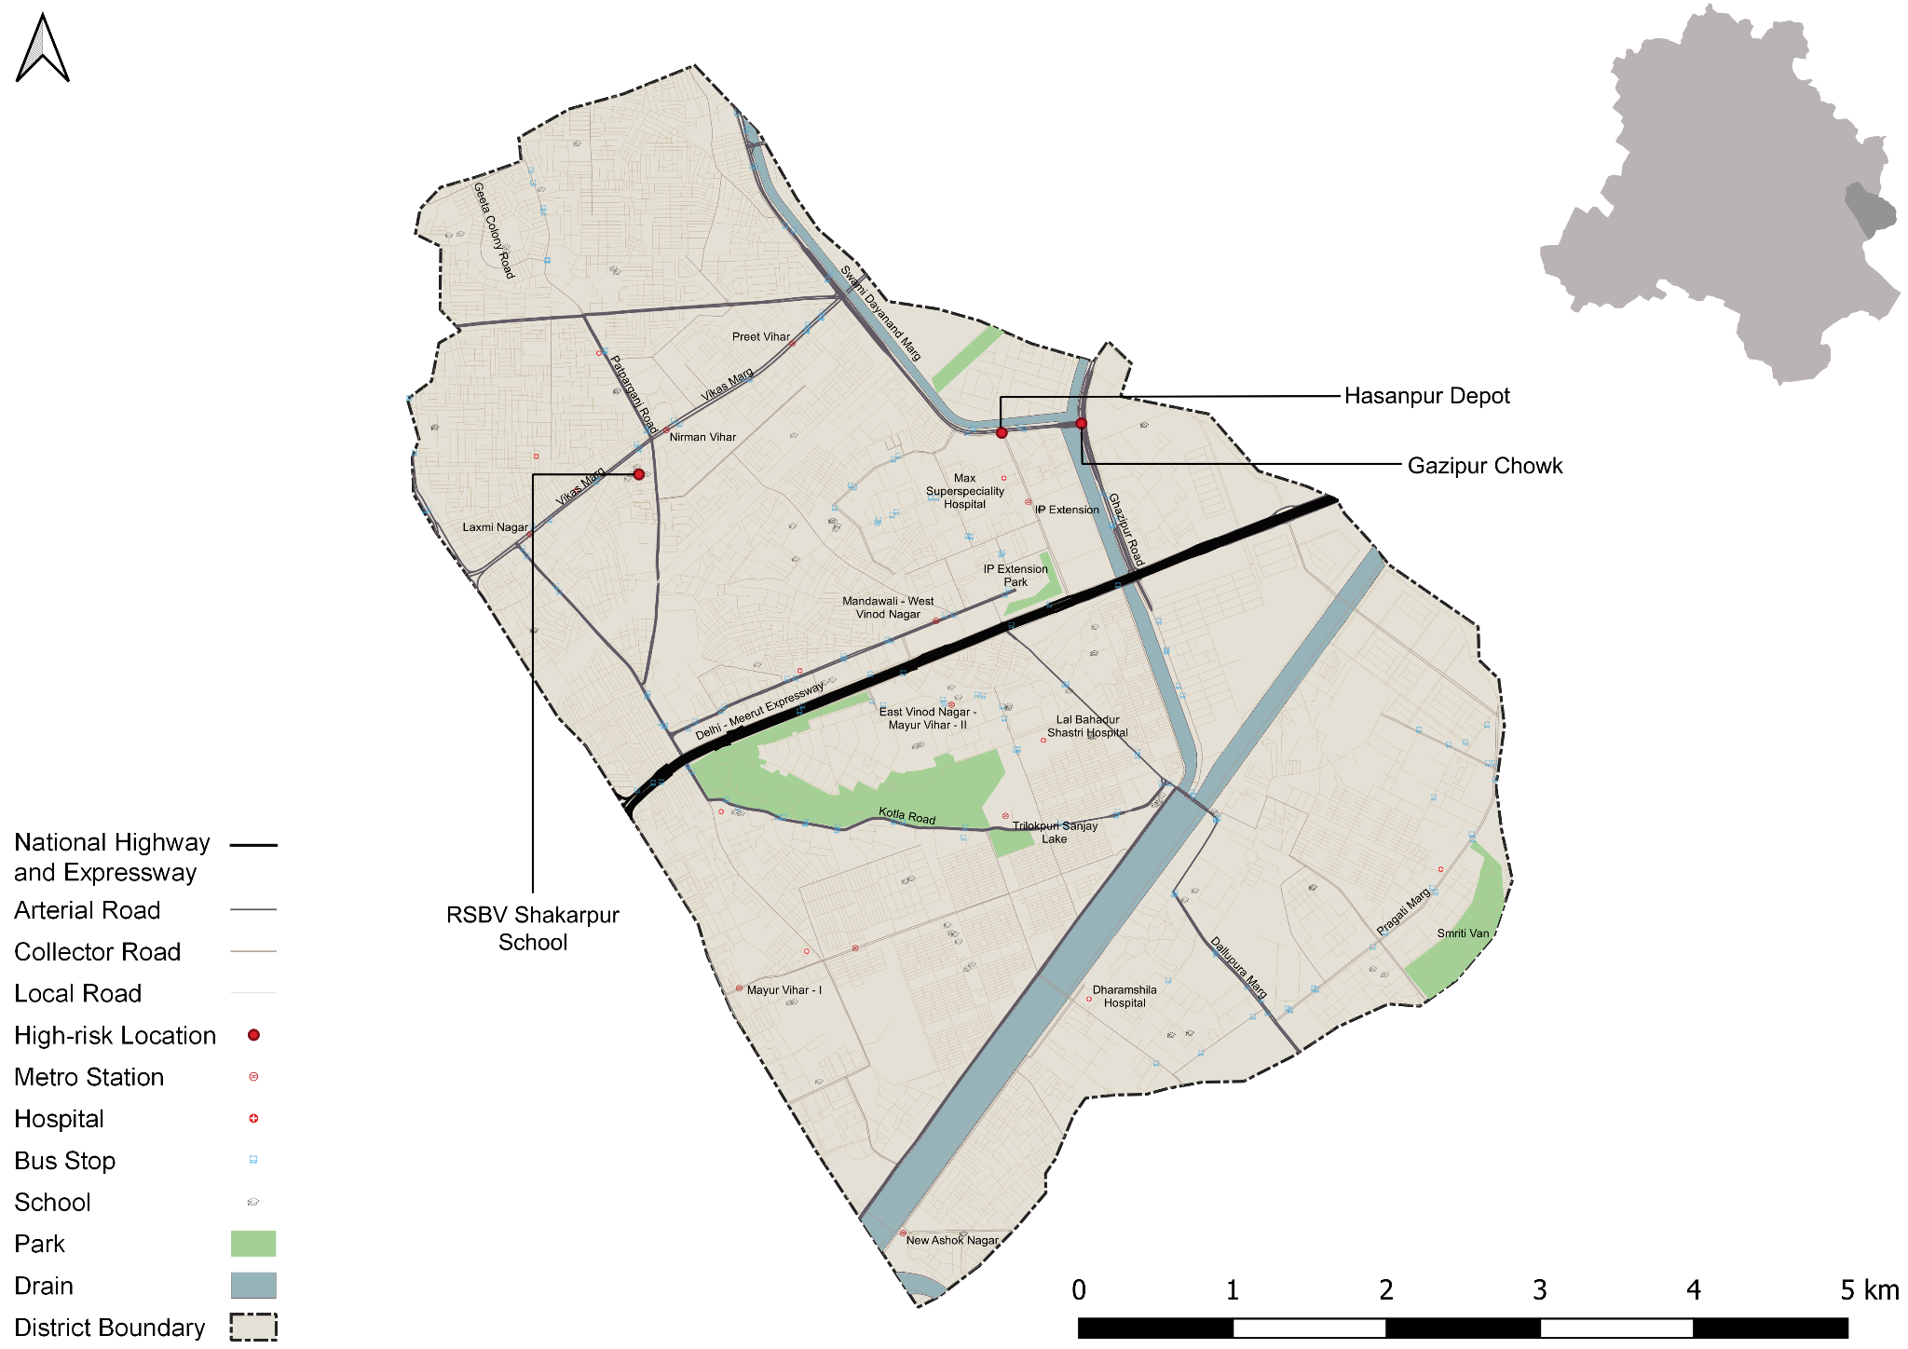

Figure : Map of all high-risk locations intervened in East District

### : High risk corridors

Figure ; Vulnerable Road users on corridors

Figure : Vulnerable Road users’ death per km

# **: Data to Action**

## : Ghazipur Roundabout

### : General Description of the site

Ghazipur Chowk (Latitude: 28° 38 '11.26"N, Longitude: 77° 18' 52.30"E). It is a 3 Arm Junction which is signalised. The intersecting road names are Chaudhary Charan Singh Road (Arterial Road) and Swami Dayanand Road (Sub-Arterial Road).

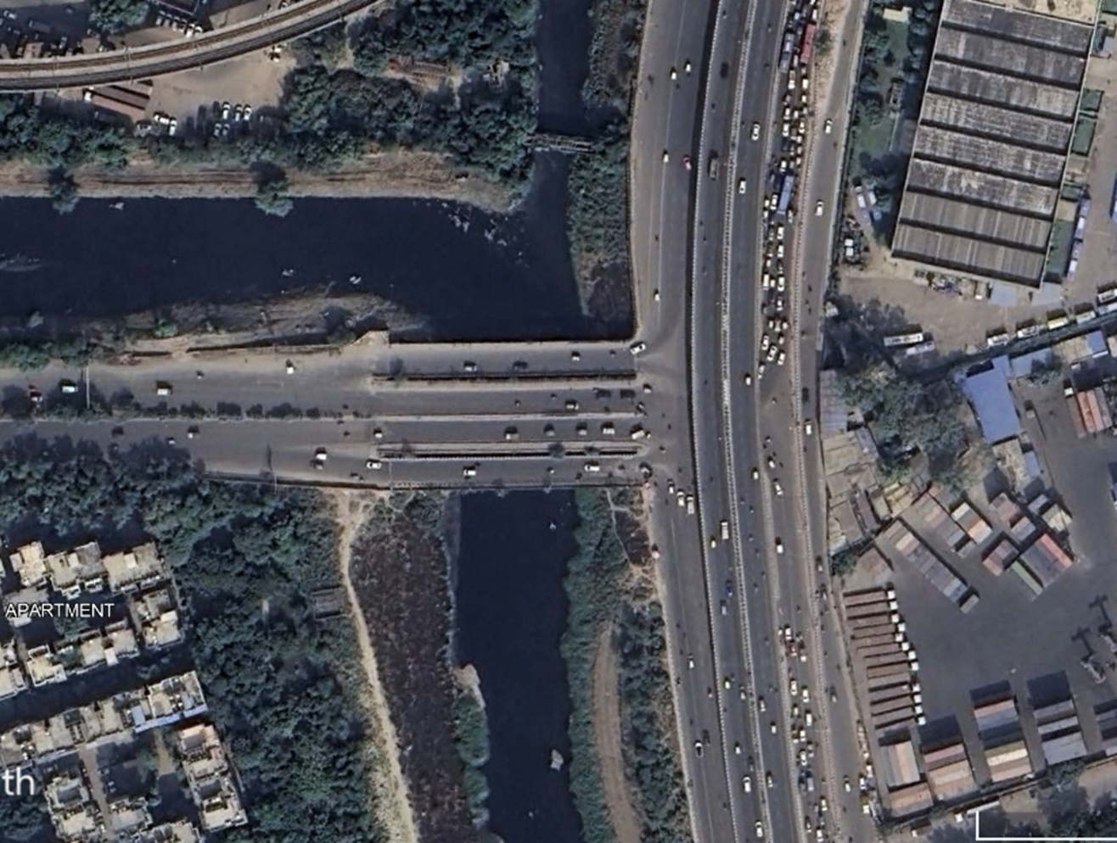

### : Existing Land Use

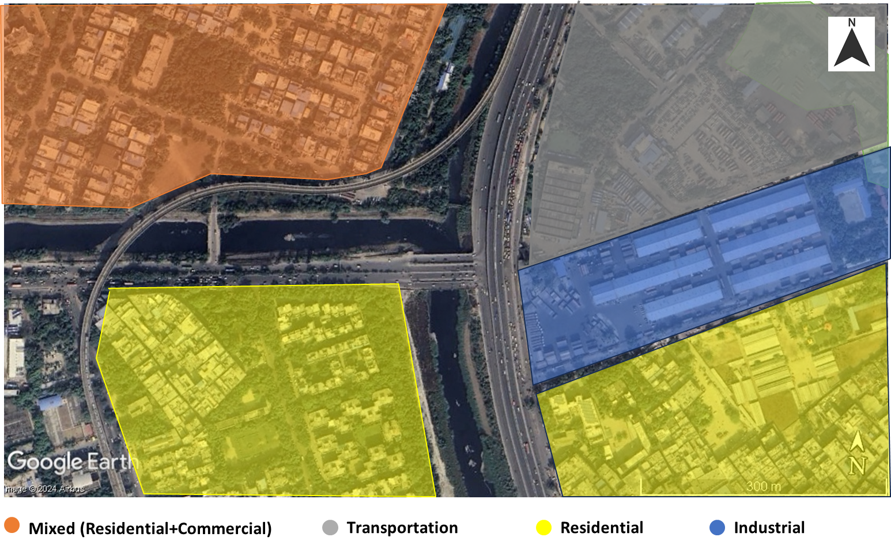

### : Conflict Points

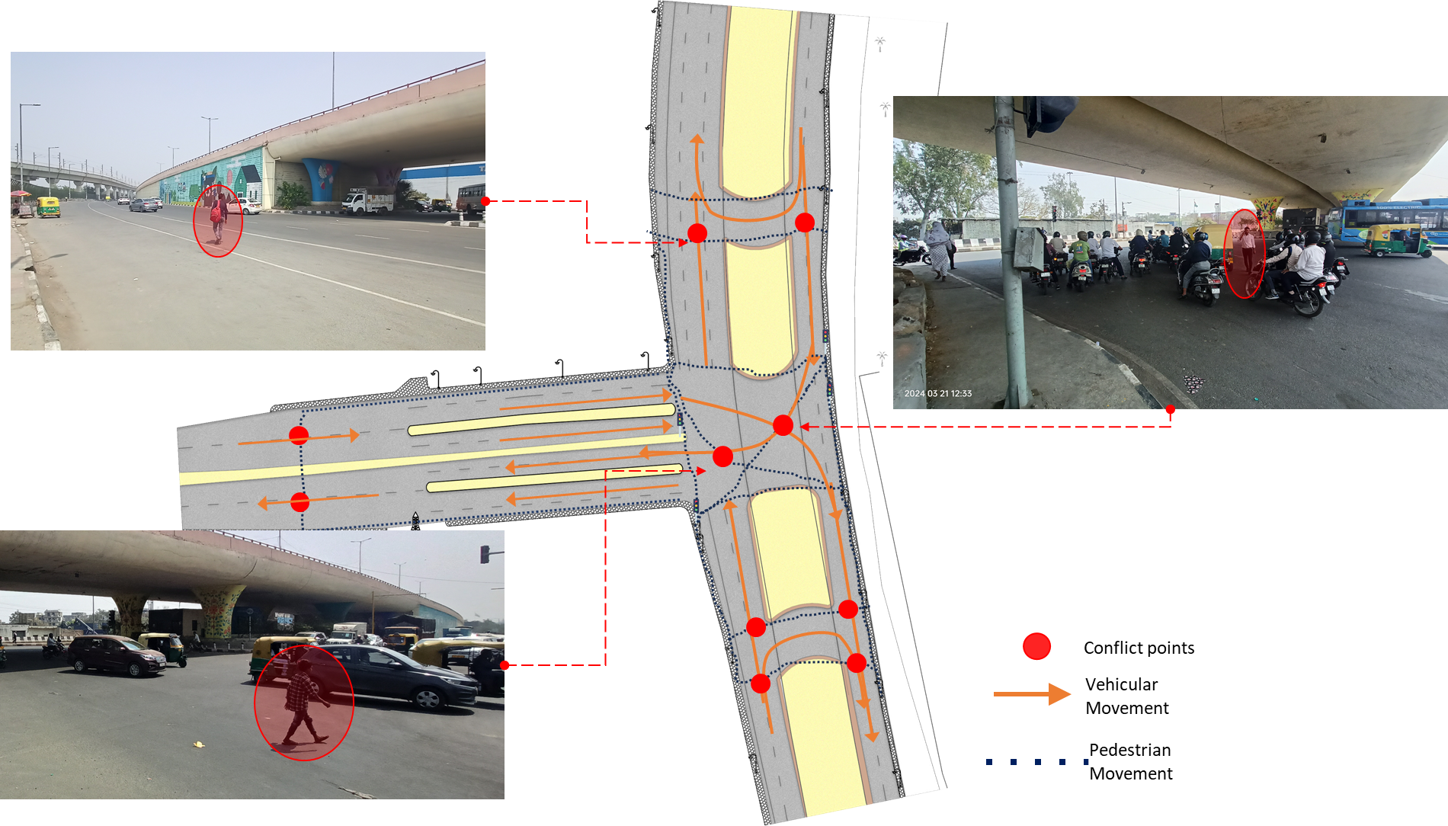

### : Existing Scenario

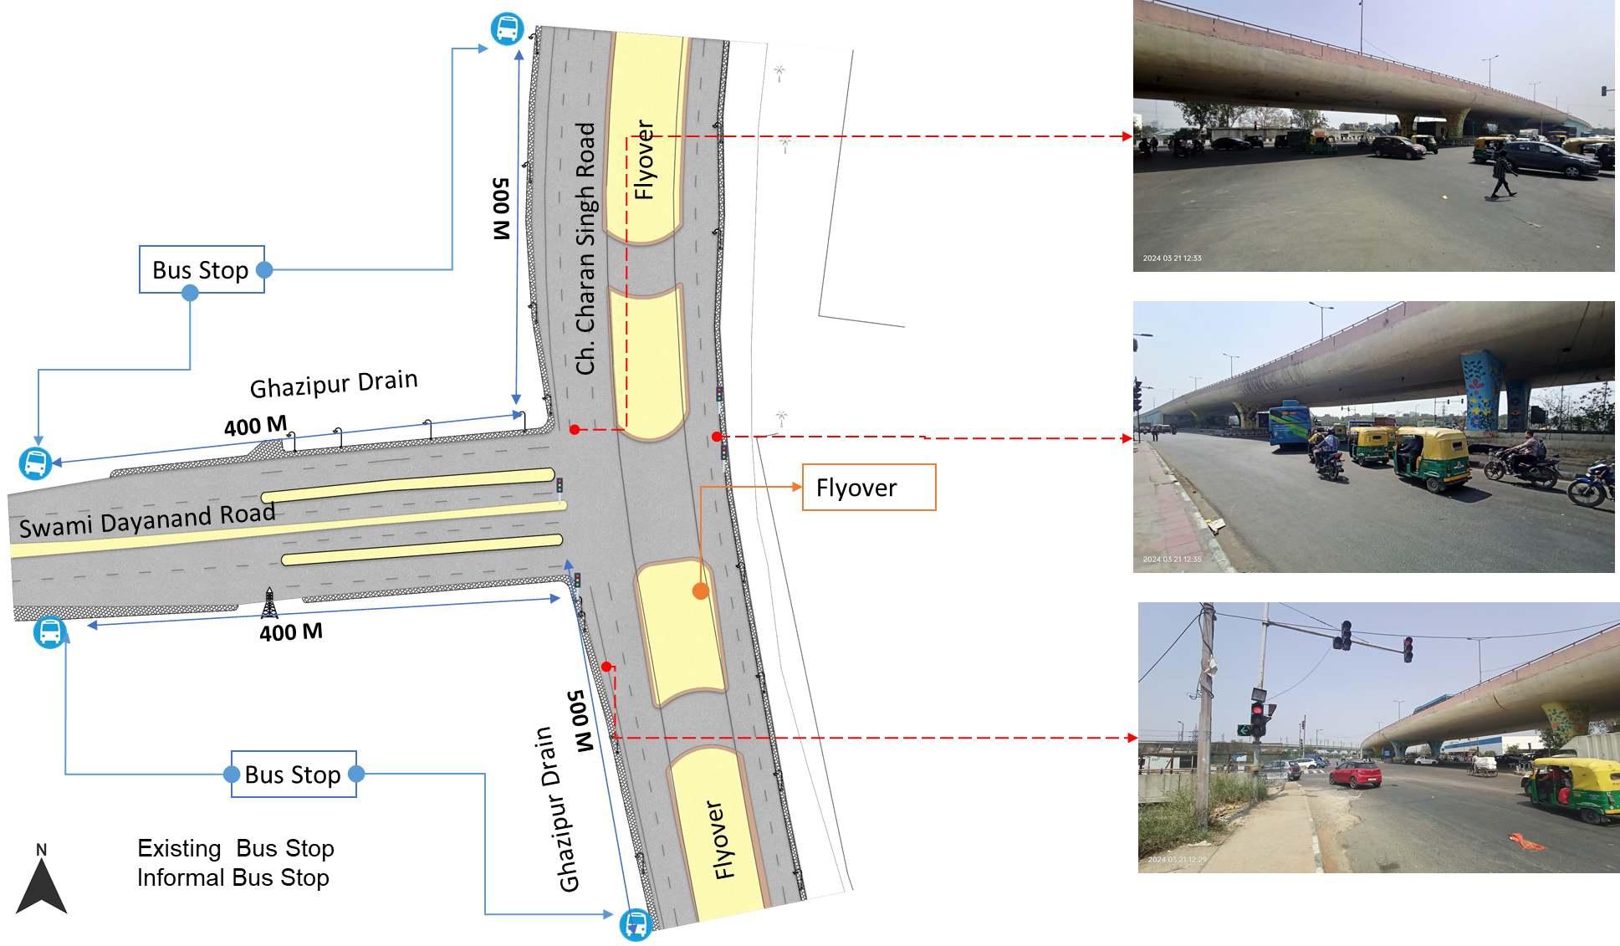

### : Issues Identified

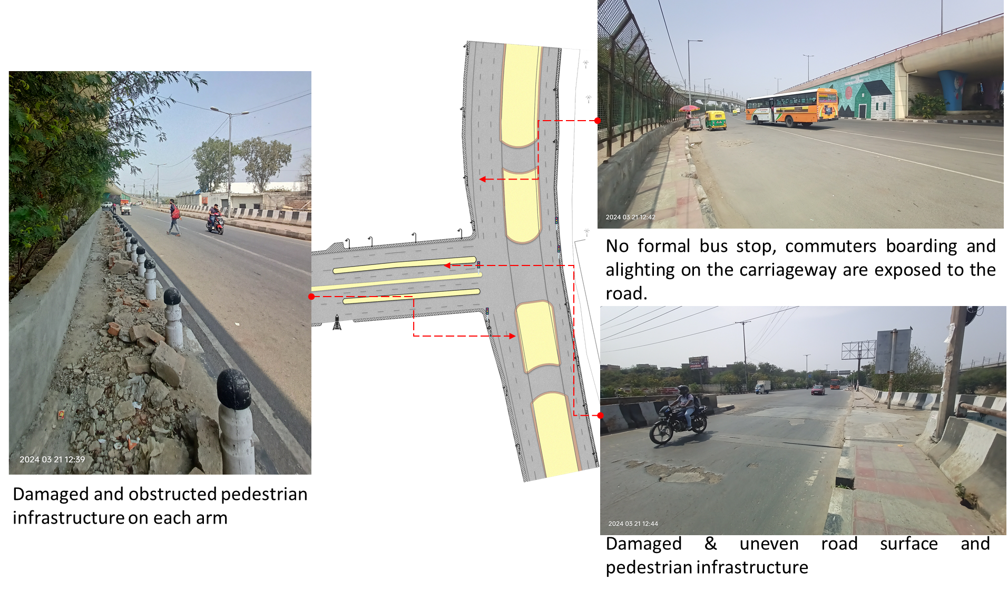

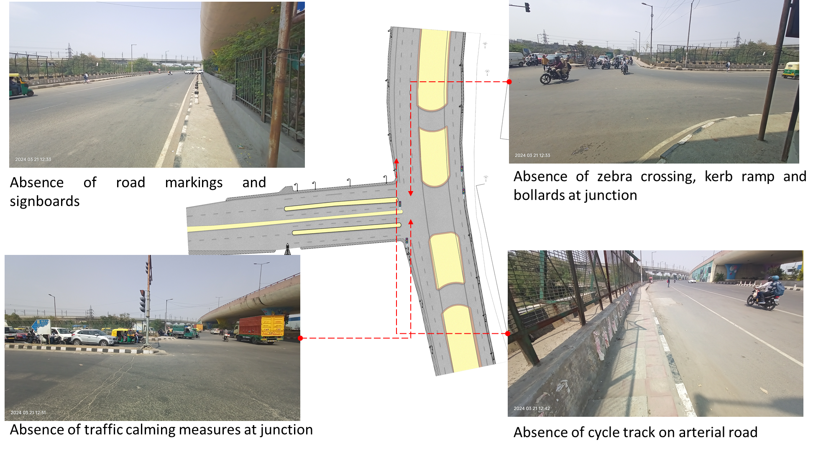

1.Absence of at-grade pedestrian infrastructure at the junction, making the pedestrians extremely vulnerable among the high-speed traffic movement.

2.Damaged and obstructed pedestrian infrastructure on each arm

3.Damaged & uneven road surface

4.Absence of tactile flooring for differently abled users.

5.Absence of traffic calming near junctions (to control the speed of vehicles).

6.Absence of road markings, signages and speed control measures at the intersection.

7.Absence of delineators and reflectors on the median and carriageway edges.

8.Absence of chevron marking and hazard markers or flexible markers at bull noses.

9.Absence of segregated cycle tracks on arterial roads.

### : Proposed Design

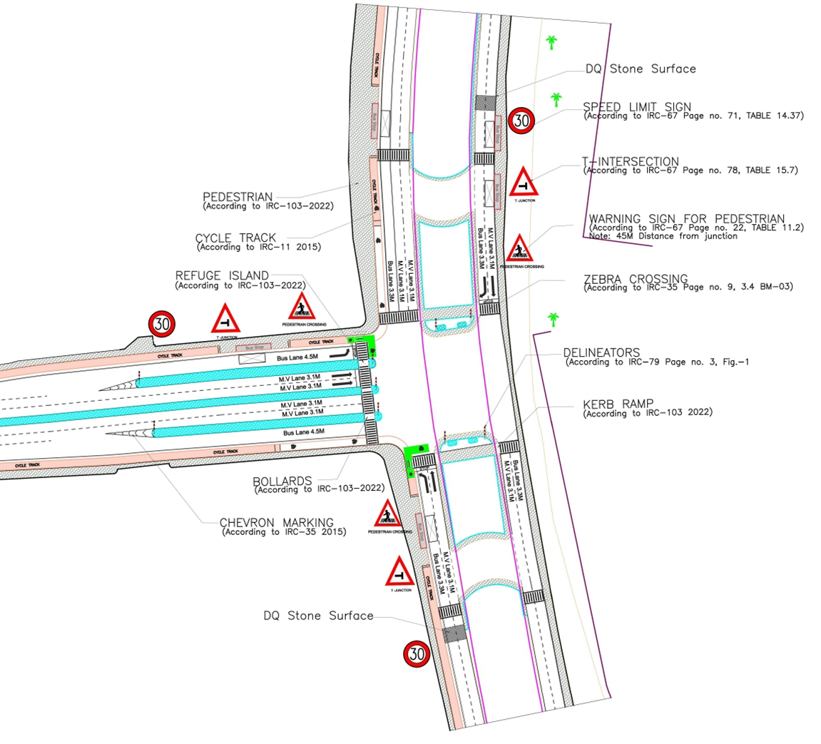

1. The junction is redesigned for the speed of 30 km/hr to ensure safety.
2. Proposed at-grade pedestrian infrastructure to increase the accessibility and safety for pedestrians
3. Proposed new bus stop near the junction to reduce the pedestrian crossing movement
4. Dedicated 2.5m wide cycle track to separate the motor traffic and the cyclists (as per IRC: 11-2015)
5. Installation of signages - Speed Limit, stop sign, pedestrian crossing and other necessary Signages on all approaching roads
6. Provision of DQ stone surface to slow down the through traffic.
7. Road Markings (as per IRC 35).
8. Provision of kerb ramps for the accessibility of differently abled users (as per IRC:103-2022).
9. Provision of chevron marking and hazard markers or flexible markers at bull noses.

### : Summary budget estimates

| **S.No** | **Component** | **Details** | **Notes** | **Rate (per sq.m)** | **Cost (INR)** | **Cost (INR, crores)** |
| --- | --- | --- | --- | --- | --- | --- |
| **A** | **CIVIL WORK** |  |  |  |  |  |
| A.1 | Footpath (Primary, Secondary including other Flooring area) | 2m to 3m wide segregated footpath with tactile pavers | Providing and laying of footpath 2m to 3m wide, including earthwork and base layer - PCC, GSB and finishing material. | 2610 | 8,587,264 | 0.859 |
| A.2 | Raised Crossing | Raised crossing with 80mm thick pavers and DQ stone surface | Providing and laying Raised crossing with 80 mm thick pavers blocks, and DQ stone including Earth work and Base layers- PCC (M15), RCC (M30 Design mix) & GSB etc. | - | - | 0.000 |
| A.3 | Cycle Infrastructure | 2.5m wide segregated cycle track | Providing and laying cycle track (2.5mt wide segregated) including Earth work and Base layers- PCC (M15), RCC (M40 Design mix) & GSB etc. also thermoplastic paint for marking and cycle symbol and spring post etc | 3765 | 3,388,540 | 0.339 |
| A.4 | CC Items (Kerbs, Pipe, etc) | Kerb stones, Bollards, Kerb Channels etc. | Providing and fixing Kerbs, Bollards, and Kerb Channel etc. in CC. |  | 1,170,790 | 0.117 |
| A.5 | Signages | Mandatory, Cautionary and Informatory Sign Boards of different sizes | Providing and fixing Signage Mandatory, Cautionary and informatory sign board including all the fixing and labours etc. |  | 72,548 | 0.007 |
| A.6 | Marking | Thermoplastic Paint Marking (Edge lines, Centre Line, Lane Marking, Hazard Marking, Chevron, Zebra Crossing, Bar Marking, etc) | Providing and applying road marking strips (retro- reflective) of specified shade/ colour using hot thermoplastic material for road marking . | 748 | 323,050 | 0.032 |
| A.7 | Special Zones | Provision of Sitting Bollards, CC Benches, GRC Jali, Pergola, Dustbin etc. | Miscellaneous items- Provision of Sitting Bollards, CC Benches, GRC Jali, Pergola, Dustbin etc. complete items- including foundation and fixing etc. |  | 100,880 | 0.010 |
| A.8 | Brick Work |  | Brick work with common burnt clay F.P.S. (non-modular) bricks of class designation 7.5 in foundation and plinth in: Cement mortar 1:4 (1 cement: 4 coarse sand) | 7370.65/CUM | 294,826 | 0.029 |
| A.9 | Steel Reinforcement for RCC work |  | Steel reinforcement (in per kg) for R.C.C. work including straightening, cutting, bending, placing in position and binding all complete up to plinth level. Thermo-Mechanically Treated bars of grade Fe-500D or more | 107.85/kg | 43,140 | 0.004 |
| A.10 | Pavement Surface Dressing | Pavement of Bitumen layer on existing road surface | Surface dressing on old surface with hot bitumen of grade VG - 10 | 175.10 / sq.m | 1,742,245 | 0.174 |
| A.11 | Safety Management Equipment (as per design requirement) | Provision of Delineator Post, Spring Post, Cat eye/studs etc. | Miscellaneous items for Safety Management Equipment (as per design requirement) -Provision of Delineator Post, Spring Post, Cat eye/studs etc.- including foundation and fixing etc. |  | 116,365 | 0.012 |
| A.12 | Bus Shelter | 10.5mX2.5m Bus Shelter (Stainless Steel Structure) |  |  | 7,200,000 | 0.720 |
|  | **SUBTOTAL CIVIL WORK (A)** |  |  |  | **23,039,647** | 2.304 |
| **B** | Drainage, Irrigation & Plumbing | (Drainage items based on design proposal) | Drainage, Irrigation & Plumbing work @ 20% of the cost of Civil work | 20% | **4,607,929** | 0.461 |
| **C** | Electrical Work | (Light poles, junction box, other electrical works proposed based on design proposal) | Electrical work @25% of the cost of Civil work | 25% | **5,759,912** | 0.576 |
| **D** | Horticulture Work | (Landscape items based on design proposal) | Horticulture work @ 15% of the cost of Civil work | 15% | **3,455,947** | 0.346 |
| **E** | Dismantling / Demolition | -- | Dismantling work @ 15% of the cost of Civil work | 15% | **3,455,947** | 0.346 |
| **F** | Work Zone Safety & Management | -- | Work zone Management @ 5% of the cost of Civil work | 5% | **1,151,982** | 0.115 |
| **PART 1** | **SUBTOTAL PART 1 (A+B+C+D+E+F)** |  |  |  | **41,471,365** | 4.147 |
| **G** | Design Services & Support | -- | Design Consultancy (Preparation of Drawings, BOQ support, Work Zone plan, Site Supervision, Community Engagement & Liaison, Change Management @ 2% - 8% of the cost of Civil work. | **2%** | **829,427** | 0.083 |
| **H** | Survey Cost | -- | Survey Cost (Total Station Survey, underground services, tree demarcation, girths, level differences, steps etc @ (80,000 per junction - 250m on each arm) | 80000 | **80,000** | 0.008 |
| **PART 2** | **SUBTOTAL PART 2 (PART 1 + G +H)** |  |  |  | **42,380,793** | 4.238 |
| **J** | Contingencies '2.5% | -- | Contingencies (@2.5% ) |  | **1,059,520** | 0.106 |
| **I** | GST ('@18%) | -- | GST @18% |  | **7,819,256** | 0.782 |
| **FINAL** | **GRAND TOTAL (PART 2 + J + I)** |  |  |  | **51,259,569** | 5.126 |

**Notes:**

1. This is a preliminary estimate. Final costing to be evaluated & approved by the road owning agency.
2. DSR 2023 has been followed for all rates. Market Rate and Costing from part PWD projects has been included for certain items.
3. Cost of Drainage, Irrigation, Plumbing has been calculated at 20% of the civil work cost.
4. Cost of Electrical Work can be calculated at 20% - 25 % of the civil work cost.
5. Cost of Horticulture has been calculated at 15% of the civil work cost.
6. Cost of Dismantling has been calculated at 15% of the civil work cost.
7. Cost of Work Zone Management has been calculated at 5% of the civil work cost
8. Cost for Design Support can range from 2% - 8%, can vary from site to site. This should include Technical Assistance on drawings, 3D supports, Site Supervision, Change management.
9. Bus Shelter has been calculated at 18 L per shelter; can be changed as per design specific cost.
10. In case of new items specific to design, please add relevant rows in detail budget estimation and include the same in the budget summary under relevant head.

## : Hasanpur Depot

### : General description of the site

Hasanpur Depot Intersection (Latitude: 28°38'9.56"N, Longitude: 77°18'32.76"E). It is a 3-arm signalised junction. This intersection is intersecting Swami Dayanand Road (Sub-Arterial Road) and Road Number 57A (Collector Road).

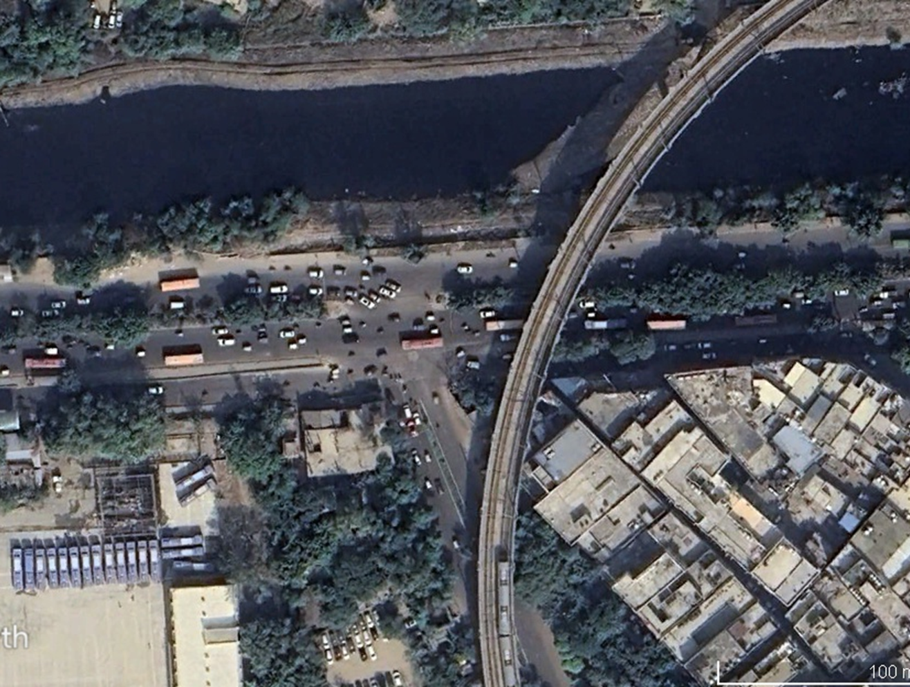

### : Existing Land Use

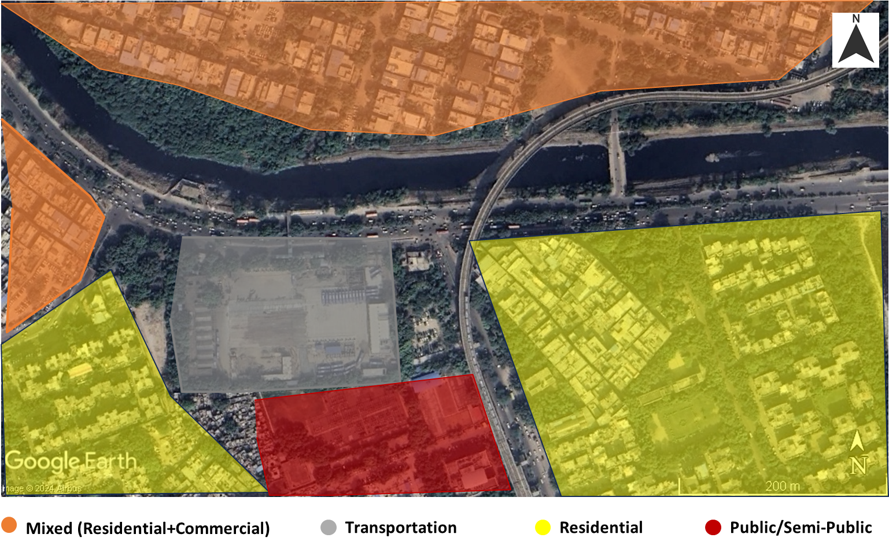

### : Existing Scenario

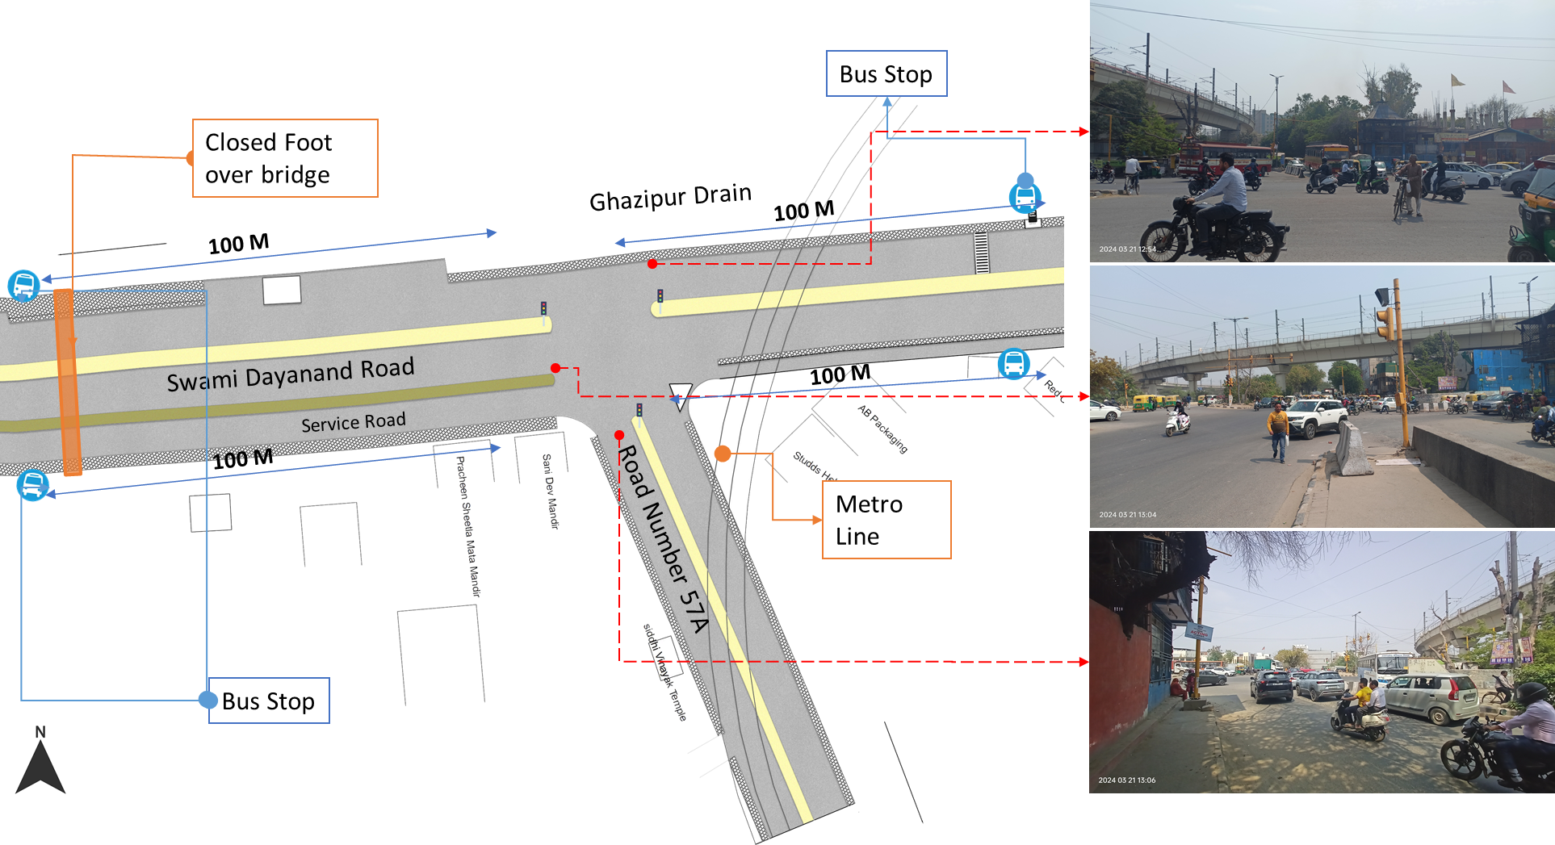

### : Issues identified

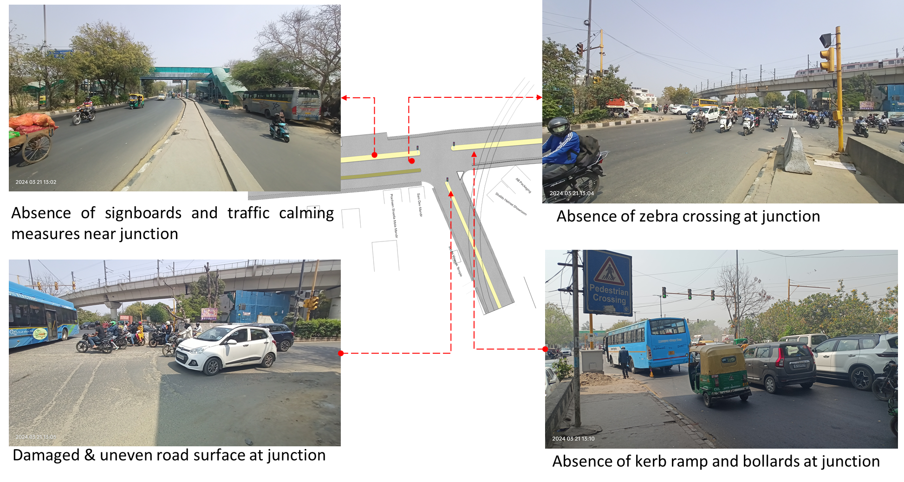

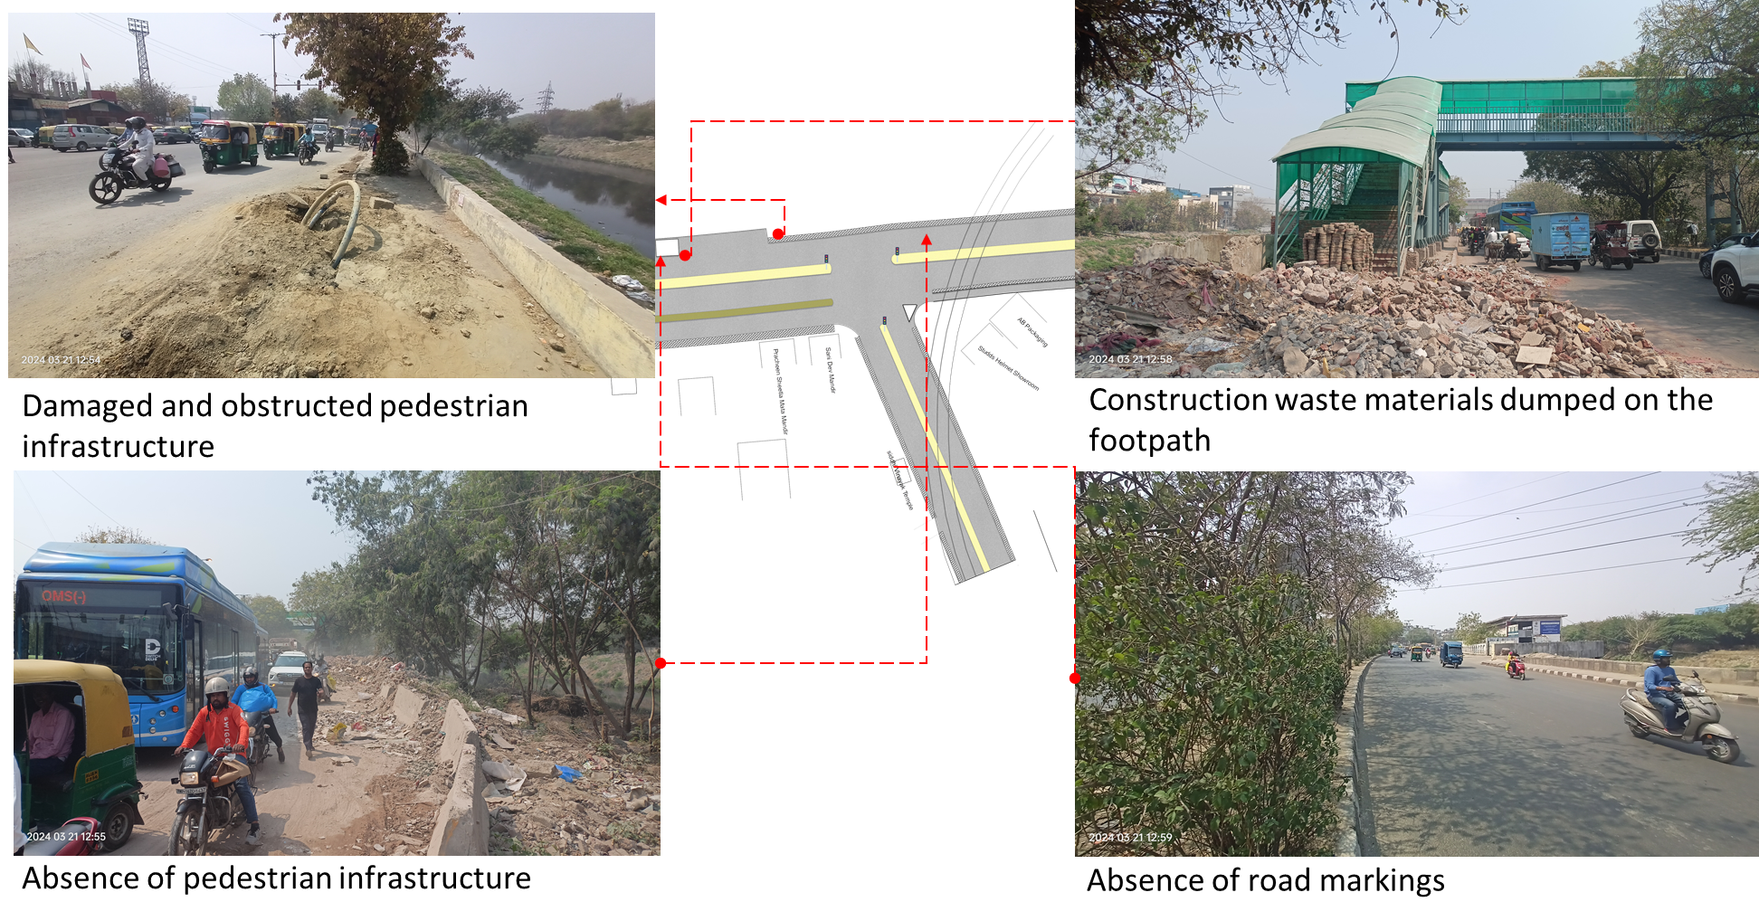

1.Absence of at-grade pedestrian infrastructure at the junction, making the pedestrians extremely vulnerable among the high-speed traffic movement.

2.Damaged and obstructed pedestrian infrastructure on each arm with dumped construction waste.

3.Damaged & uneven road surface

4.Absence of kerb ramp and tactile flooring for differently abled users.

5.Absence of traffic calming near junctions (to control the speed of vehicles).

6.Absence of road markings, signages and speed control measures at the intersection.

7.Absence of delineators and reflectors on the median and carriageway edges.

8.Absence of chevron marking and hazard markers or flexible markers at bull noses.

9.Absence of segregated cycle tracks on sub-arterial roads.

### : Proposed Design

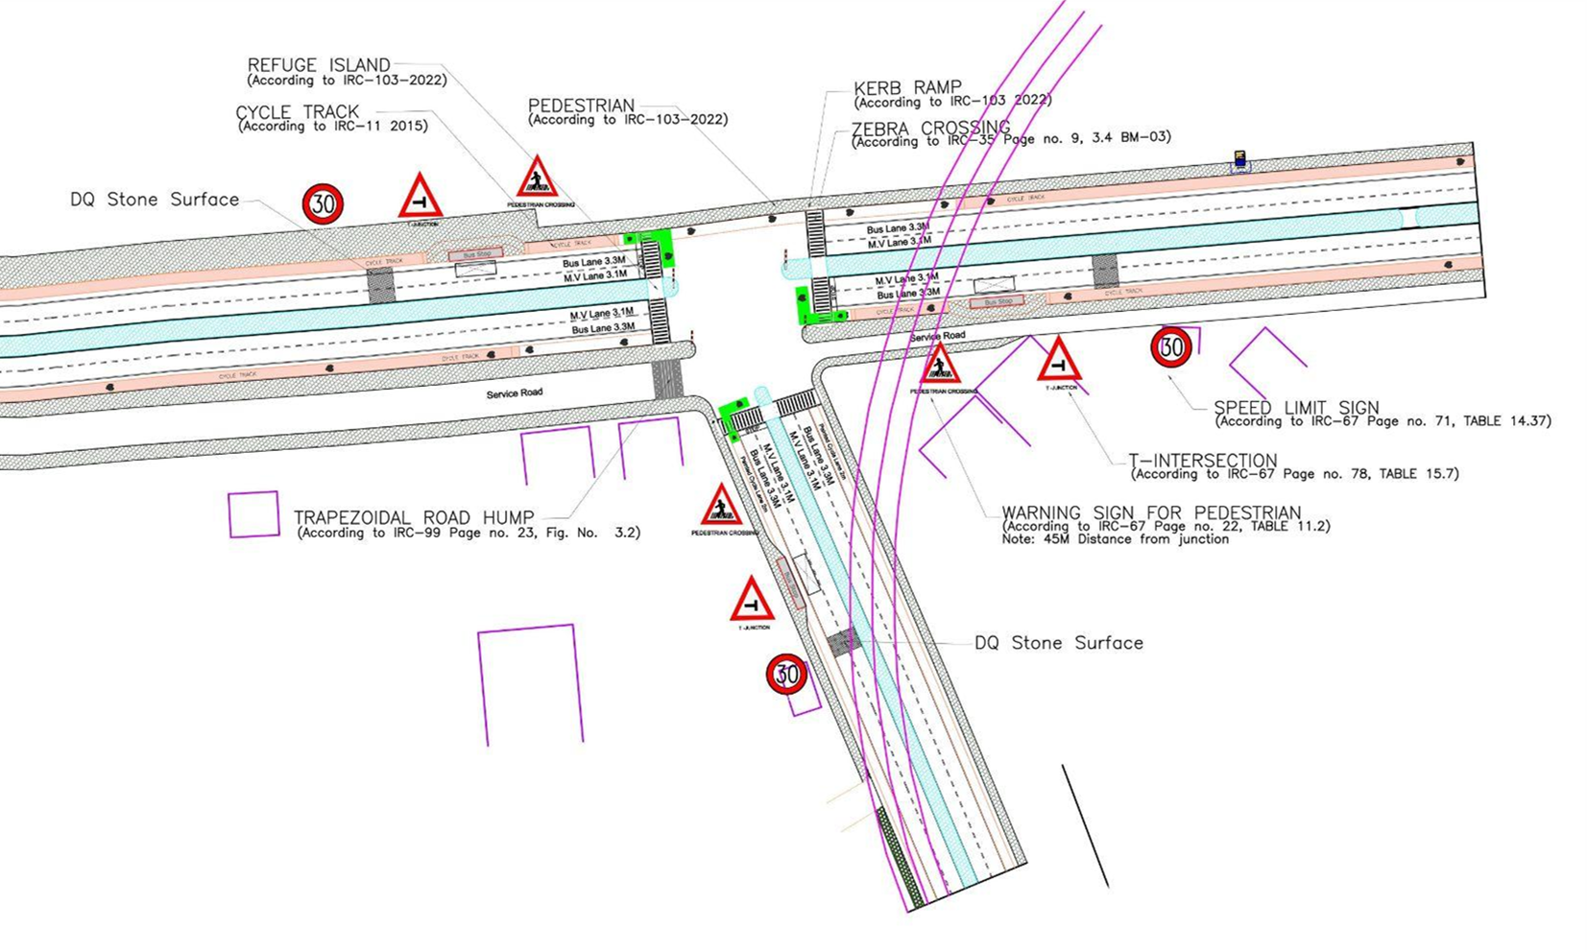

1. The junction is redesigned for the speed of 30 km/hr to ensure safety.
2. The junction is redesigned for the speed of 30 km/hr to ensure safety.
3. Proposed new bus stop near the junction to reduce the pedestrian crossing movement.
4. Dedicated 2.5m wide cycle track and cycle lane to separate the motor traffic and the cyclists (as per IRC: 11-2015).
5. Installation of signages - Speed Limit, stop sign, pedestrian crossing and other necessary Signages on all approaching roads.
6. Provision of DQ stone surface to slow down the approaching traffic.
7. Road Markings (as per IRC 35).
8. Provision of kerb ramps for the accessibility of differently abled users (as per IRC:103-2022).
9. Provision of trapezoidal humps and speed humps on the service road access.

### : Summary budget estimates

| **S.No** | **Component** | **Details** | **Notes** | **Rate (per sq.m)** | **Cost (INR)** | **Cost (INR, crores)** |
| --- | --- | --- | --- | --- | --- | --- |
| **A** | **CIVIL WORK** |  |  |  |  |  |
| A.1 | Footpath (Primary, Secondary including other Flooring area) | 2m to 3m wide segregated footpath with tactile pavers | Providing and laying of footpath 2m to 3m wide, including earthwork and base layer - PCC, GSB and finishing material. | 2618 | 10,339,739 | 1.034 |
| A.2 | Raised Crossing | Raised crossing with 80mm thick pavers and DQ stone surface | Providing and laying Raised crossing with 80 mm thick pavers blocks, and DQ stone including Earth work and Base layers- PCC (M15), RCC (M30 Design mix) & GSB etc. | 3843 | 199,829 | 0.020 |
| A.3 | Cycle Infrastructure | 2.5m wide segregated cycle track | Providing and laying cycle track (2.5mt wide segregated) including Earth work and Base layers- PCC (M15), RCC (M40 Design mix) & GSB etc. also thermoplastic paint for marking and cycle symbol and spring post etc | 4048 | 5,214,343 | 0.521 |
| A.4 | CC Items (Kerbs, Pipe, etc) | Kerb stones, Bollards, Kerb Channels etc. | Providing and fixing Kerbs, Bollards, and Kerb Channel etc. in CC. |  | 1,457,092 | 0.146 |
| A.5 | Signages | Mandatory, Cautionary and Informatory Sign Boards of different sizes | Providing and fixing Signage Mandatory, Cautionary and informatory sign board including all the fixing and labours etc. |  | 72,548 | 0.007 |
| A.6 | Marking | Thermoplastic Paint Marking (Edge lines, Centre Line, Lane Marking, Hazard Marking, Chevron, Zebra Crossing, Bar Marking, etc) | Providing and applying road marking strips (retro- reflective) of specified shade/ colour using hot thermoplastic material for road marking. | 748 | 323,050 | 0.032 |
| A.7 | Special Zones | Provision of Sitting Bollards, CC Benches, GRC Jali, Pergola, Dustbin etc. | Miscellaneous items- Provision of Sitting Bollards, CC Benches, GRC Jali, Pergola, Dustbin etc. complete items- including foundation and fixing etc. |  | 100,880 | 0.010 |
| A.8 | Brick Work |  | Brick work with common burnt clay F.P.S. (non-modular) bricks of class designation 7.5 in foundation and plinth in: Cement mortar 1:4 (1 cement: 4 coarse sand) | 7370.65/CUM | 294,826 | 0.029 |
| A.9 | Steel Reinforcement for RCC work |  | Steel reinforcement (in per kg) for R.C.C. work including straightening, cutting, bending, placing in position and binding all complete up to plinth level. Thermo-Mechanically Treated bars of grade Fe-500D or more | 107.85/kg | 43,140 | 0.004 |
| A.10 | Pavement Surface Dressing | Pavement of Bitumen layer on existing road surface | Surface dressing on old surface with hot bitumen of grade VG - 10 | 175.10 / sq.m | 262,650 | 0.026 |
| A.11 | Safety Management Equipment (as per design requirement) | Provision of Delineator Post, Spring Post, Cat eye/studs etc. | Miscellaneous items for Safety Management Equipment (as per design requirement) -Provision of Delineator Post, Spring Post, Cat eye/studs etc.- including foundation and fixing etc. |  | 97,961 | 0.010 |
|  | **SUBTOTAL CIVIL WORK (A)** |  |  |  | **18,406,057** | 1.841 |
| **B** | Drainage, Irrigation & Plumbing | (Drainage items based on design proposal) | Drainage, Irrigation & Plumbing work @ 20% of the cost of Civil work | 20% | **3,681,211** | 0.368 |
| **C** | Electrical Work | (Light poles, junction box, other electrical works proposed based on design proposal) | Electrical work @25% of the cost of Civil work | 25% | **4,601,514** | 0.460 |
| **D** | Horticulture Work | (Landscape items based on design proposal) | Horticulture work @ 15% of the cost of Civil work | 15% | **2,760,908** | 0.276 |
| **E** | Dismantling / Demolition | -- | Dismantling work @ 15% of the cost of Civil work | 15% | **2,760,908** | 0.276 |
| **F** | Work Zone Safety & Management | -- | Work zone Management @ 5% of the cost of Civil work | 5% | **920,303** | 0.092 |
| **PART 1** | **SUBTOTAL PART 1 (A+B+C+D+E+F)** |  |  |  | **33,130,902** | 3.313 |
| **G** | Design Services & Support | -- | Design Consultancy (Preparation of Drawings, BOQ support, Work Zone plan, Site Supervision, Community Engagement & Liaison, Change Management @ 2% - 8% of the cost of Civil work. | **2%** | **662,618** | 0.066 |
| **H** | Survey Cost | -- | Survey Cost (Total Station Survey, underground services, tree demarcation, girths, level differences, steps etc @ (80,000 per junction - 250m on each arm) | 80000 | **80,000** | 0.008 |
| **PART 2** | **SUBTOTAL PART 2 (PART 1 + G +H)** |  |  |  | **33,873,520** | 3.387 |
| **J** | Contingencies '2.5% | -- | Contingencies (@2.5%) |  | **846,838** | 0.085 |
| **I** | GST ('@18%) | -- | GST @18% |  | **6,249,664** | 0.625 |
| **FINAL** | **GRAND TOTAL (PART 2 + J + I)** |  |  |  | **40,970,022** | 4.097 |

**Notes:**

1. This is a preliminary estimate. Final costing to be evaluated & approved by the road owning agency.
2. DSR 2023 has been followed for all rates. Market Rate and Costing from part PWD projects has been included for certain items.
3. Cost of Drainage, Irrigation, Plumbing has been calculated at 20% of the civil work cost.
4. Cost of Electrical Work can be calculated at 20% - 25 % of the civil work cost.
5. Cost of Horticulture has been calculated at 15% of the civil work cost.
6. Cost of Dismantling has been calculated at 15% of the civil work cost.
7. Cost of Work Zone Management has been calculated at 5% of the civil work cost
8. Cost for Design Support can range from 2% - 8%, and can vary from site to site. This should include Technical Assistance on drawings, 3D supports, Site Supervision, Change management.
9. Bus Shelter has been calculated at 18 L per shelter; can be changed as per design specific cost.
10. In case of new items specific to design, please add relevant rows in detail budget estimation and include the same in the budget summary under relevant head.

## : Safe School Zone: Rajkiya Sarvodaya Bal Vidyalaya (RSBV), Shakarpur

### : General description of the site

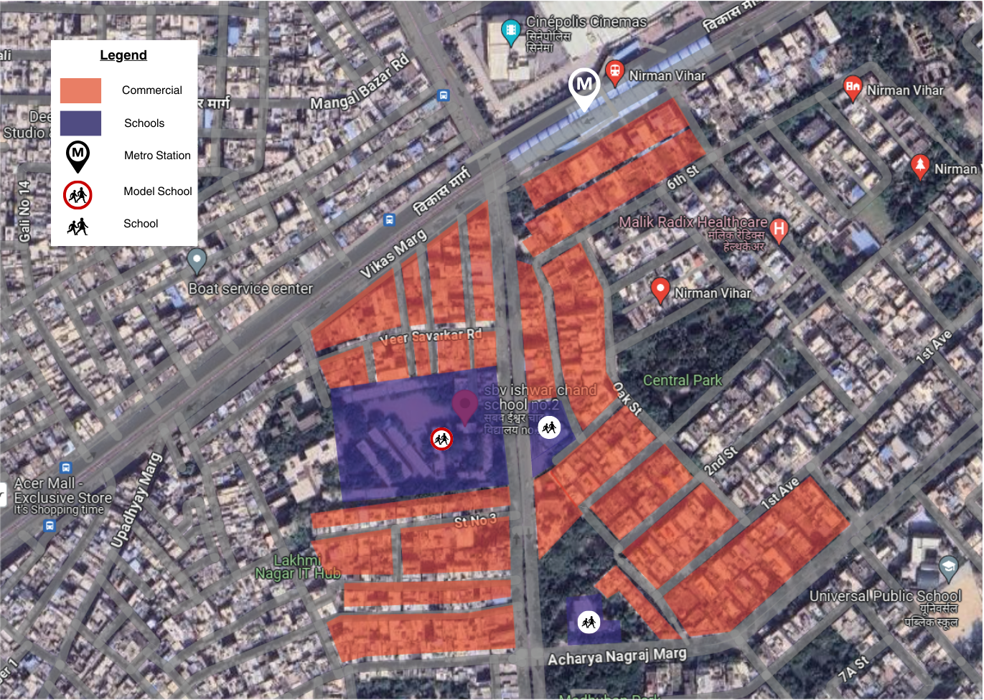

*Figure B.3.2: Land Use Map of Rajkiya Sarvodaya Bal Vidyalaya and School Zone Data (AY 22-23)*

|  |  |  |  |  |  |  |
| --- | --- | --- | --- | --- | --- | --- |
| District | Co-ed | School Shift | Shared Campus | Cluster of Schools | Total No. of Students: | ROW |
| East | No | Morning | Yes | Yes | 1829 | 22m - 24m |

Length of Intervention (all arms, in metres) : 450

Situated at the Patparganj Road between the Nirman Vihar and Acharya Nagraj Marg intersection, the Rajkiya Sarvodaya Bal Vidyalaya (RSBV) is the pilot safe school site in the East district. With a cluster of 3 schools, the site was identified as a potential crash location as per the Action to data report 2022-23. The school is surrounded in the vicinity with the land use predominantly commercial in nature and other schools. The school has a total of two gates. Both gate no. 1, and 2 opens at the Patparganj road. RSBV is a shift school with a total enrolment of 1829 students from class I to XII (age 7 to age 17). With a varied wing distribution of 20.2% in junior, 27.3% in middle and 52.4% in senior secondary, the school thus has children from age 5 to 17 travelling to and from school. The larger modes of transport observed in the school surroundings are walk and public transport.

### : Existing Scenario

As per a travel survey conducted in Dec ‘22, response from 267 students (15% of total school population) was mapped to understand travel patterns and socio-emotional data relevant to school journeys.

Figure : Home to school modal distribution: Rajkiya Sarvodaya Bal Vidyalaya

Figure : School to home modal distribution: Rajkiya Sarvodaya Bal Vidyalaya

*Source: HumanQind School Travel Survey 22-23*

* Walking is the single most common mode of transport for the students both in the afternoon and evening.
* 24% in the afternoon and 20% of the students in the evening travel by public transport.
* Private vehicles and auto rickshaws are one of the least commonly used modes.
* Between afternoon and evening there is a minor modal shift between the walking students and those using public transport although their total numbers remain nearly the same.
* 76% of the students stay within 2 km of the school, and nearly 40% live within 1 km of the school.
* Only 8% of the students come from more than 2 km.
* 17% of the students reported fear while travelling to and back from the school.
* 67% of the students reported they felt safe and 16% gave no reply to the question.
* Amongst the modes public transport and bicycles were reported as the modes where the students felt the most unsafe; with an average 30% and 27% reporting they felt fear while travelling respectively.
* In other modes, less than 15% of the students reported feeling unsafe.

### : Issues identified

**Observations on Road Infrastructure:** Due to the traditional vehicle centric planning approach, the road infrastructure does not adhere to safety principles as per IRCs. This leads to an unsafe environment for the vulnerable road users. There have been observations about high speeding and wrong side driving because of the lack of any traffic calming devices, signages and marking conducive to school zones. With that, there is a lack of provision in the pedestrian and cyclist infrastructure though a good number of students commute to school and back home by walking. Some additional infrastructure issues with high demand value includes, lack of dedicated parking zones, waiting areas, dedicated drop off and pick off areas and vendor/hawkers zone within the school zone and better planning of utilities.

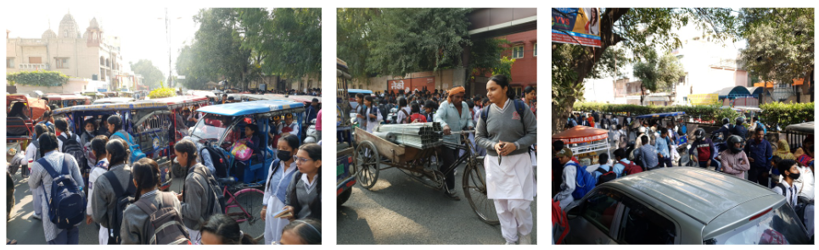

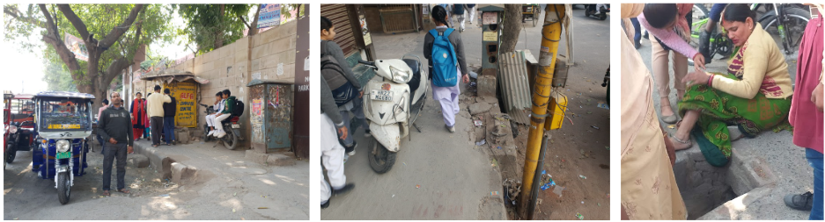

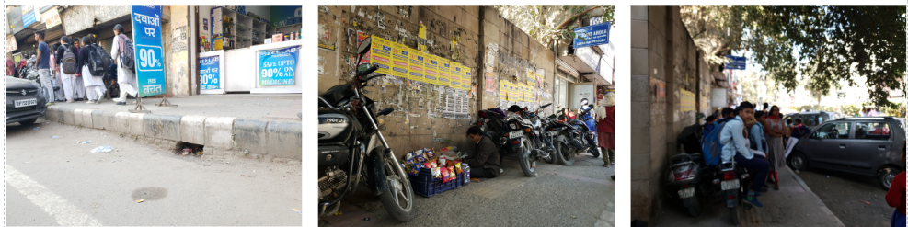

*Figure B.3.4: Site Photographs : Rajkiya Sarvodya Bal Vidyala*

**Type and Quality of Enforcement**

Lack of traffic personnel in the school vicinity leads to an uncontrolled environment and circumstances. Over speeding and wrong side driving is observed to be a common phenomenon. Especially during the active school hours, this results in conflict with vulnerable road users.

**Road Users Behaviour and mobility patterns**

To understand the regular patterns of movements and conflicts in the school vicinity, HumanQind conducted activity mapping during the active school hours for Rajkiya Sarvodaya Bal Vidyalaya. Observations were made twice in a day. First, for the morning hours i.e., to derive Home to school patterns of students. Second, in the afternoon hours i.e., to derive school to home patterns of students

### : Activity map

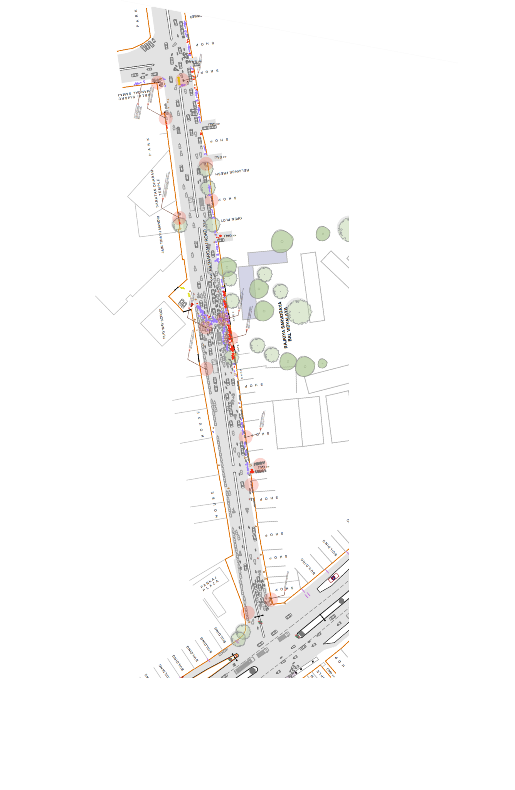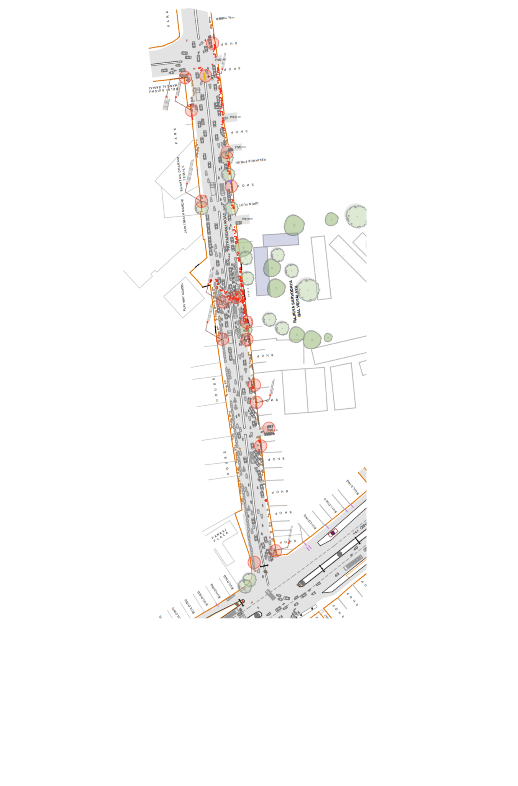

*Figure B.3.5: Activity Mapping*

**Key Findings:**

|  |  |
| --- | --- |
| **Afternoon : Home to School**   * Crowding and Haphazard movement in front of gates in the afternoon hour for shift change. * There are no waiting areas near the school gate and with the insufficient capacity of footpath this leads to a chaotic situation at the school front. * E-rickshaws and private vehicles are parked near the school gate, students find it difficult to navigate their way through. * High conflict between students and motorised vehicles is observed during the school active hours. | **Evening : School to Home**   * Students find it difficult to walk in the evening hours as there is a lack of street lighting. * High conflict between students and motorised traffic is observed in the evening hours. * Students have to cross the road in an unsafe environment. |

### : Proposed design

The proposal prepared by road safety clubs (Refer Safer Delhi through Road Safety Clubs) is called ‘Surakshit Sapna’ aligning to pedestrian first approach, traffic safety principles, UN Sustainable Development Goals and Ladder of Children Participation. ‘Surakshit Sapna’ is an area plan connecting 3 schools and the neighbourhood to 450m of school zone development. The entire plan is in adherence to Indian Road Congress Guidelines. To reduce speeds and conflicts, the school zone has been designed as per 20km/h or lower speed, promoting walkability, safe mobility. Continuous footpaths with designated boarding areas and drop off zones have been proposed. All streets are collector streets and cycle lanes with bollards have been planned. The area in front of gates, including the Nirman Vihar and Acharya Nagraj intersection have been made safer with Table top crossings, change of surface texture and prominent markings to highlight school zones for all road users.

* 2.5-2.8m accessible and segregated footpaths on both sides
* 1.2 m segregated cycle lane on one side. (as per IRC 11: 2015)
* 1.0 m of Multi-Utility Zone for Services such as lighting and drainage.
* Traffic calmings designed in front of entry/exits and school gates.
* Low medians to increase visibility.
* Designated boarding areas and drop off zones
* Integrated waiting spaces, vendor spaces and street furniture integrated
* School specific signage and marking
* Continuous carriageway 2 lanes each direction on Patparganj Road

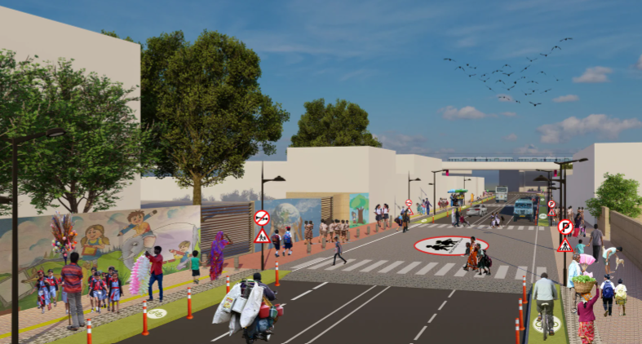

**Image B.3.6: Surakshit Sapna - Proposed Render of Patparganj Road of RajkiyaSarvodaya Bal Vidyalaya**

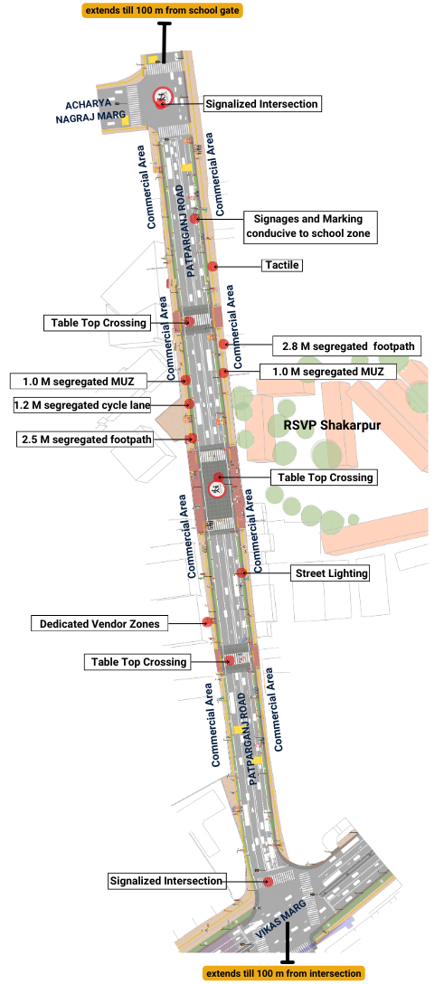

*Proposed Design for School Zone Rajkiya Sarvodya Bal Vidyalaya, Shakarpur*

### : Summary budget estimates

| **S.No** | **Component** | **Details** | **Notes** | **Rate (per sq.m)** | **Cost (INR)** | **Cost (INR, crores)** |
| --- | --- | --- | --- | --- | --- | --- |
| **A** | **CIVIL WORK** |  |  |  |  |  |
| A.1 | Footpath (Primary, Secondary including other Flooring area) | 2.5m segregated footpath with tactile pavers in both directions | Providing and Laying of footpath 2m to 3m wide, including earthwork and base layer - PCC, GSB and finishing material. | 2695 | 10199375 | 1.020 |
| A.2 | Raised Crossing | Traffic calming in front of school gate 1, intersection of som bazar road and | Providing and laying Raised crossing with 80 mm thick pavers blocks, and DQ stone including Earth work and Base layers- PCC (M15), RCC (M30 Design mix) & GSB etc. | 3587 | 3787537 | 0.379 |
| A.3 | Cycle Infrastructure | 1.5m cycle lane both sides | Providing and laying cycle track (2.5mt wide segregated) including Earth work and Base layers- PCC (M15), RCC (M40 Design mix) & GSB etc. also thermoplastic paint for marking and cycle symbol and spring post etc | 0 | 815730 | 0.082 |
| A.4 | CC Items (Kerbs, Pipe, etc) | Provision of bollards, kerbs - mountable, kerb channels, etc | Providing and fixing Kerbs, Bollards, and Kerb Channel etc. in CC. |  | 619655 | 0.062 |
| A.5 | Signages | Provision of signages as per IRC 67 for school zone & 20 km/h | Providing and fixing Signage Mandatory, Cautionary and informatory sign board including all the fixing and labours etc. |  | 384227 | 0.038 |
| A.6 | Marking | Provision of signages as per IRC 35 for school zone & 20 km/h | Providing and applying road marking strips (retro- reflective) of specified shade/ colour using hot thermoplastic material for road marking. | 1375 | 412460 | 0.041 |
| A.7 | Special Zones | Provision of seating areas, vendor spaces and play integrated with design proposal | Miscellaneous items- Provision of Sitting Bollards, CC Benches, GRC Jali, Pergola, Dustbin etc. complete items- including foundation and fixing etc. |  | 64959 | 0.006 |
| A.8 | Brick Work | -- | Brick work with common burnt clay F.P.S. (non modular) bricks of class designation 7.5 in foundation and plinth in: Cement mortar 1:4 (1 cement : 4 coarse sand) | 7370.65/CUM | 316938 | 0.032 |
| A.9 | Steel Reinforcement for RCC work | -- | Steel reinforcement (in per kg) for R.C.C. work including straightening, cutting, bending, placing in position and binding all complete upto plinth level.Thermo-Mechanically Treated bars of grade Fe-500D or more | 107.85/kg | 107850 | 0.011 |
| A.10 | Pavement Surface Dressing | Pavement of Bitumen layer on existing road surface | Surface dressing on old surface with hot bitumen of grade VG - 10 | 175.10 / sq.m | 0 | 0.000 |
| A.11 | Safety Management Equipment (as per design requirement) | Provision of Delineator Post, Spring Post, Cat eye/studs etc. | Miscellaneous items for Safety Management Equipment ( as per design requirement) -Provision of Delineator Post, Spring Post, Cat eye/studs etc.- including foundation and fixing etc. |  | 0 | 0.000 |
| A.12 | Bus Shelter | -- | Provision of new bus shelter. |  | 0 |  |
|  | **SUBTOTAL CIVIL WORK (A)** |  |  |  | **16708731** | 1.671 |
| **B** | Drainage, Irrigation & Plumbing | Details promoting a catch pit along the footpath linked to existing manholes. Bell mouths are not recommended. Details to be finalised with PWD | Drainage, Irrigation & Plumbing work @ 20% of the cost of Civil work | 20% | **3341746** | 0.334 |
| **C** | Electrical Work | 5m and 10m light poles have been located alongside the footpath / MUZ. Details to be finalised with PWD. | Electrical work @25% of the cost of Civil work | 25% | **4177183** | 0.418 |
| **D** | Horticulture Work | To increase green cover and shade, landscape plans promote ground cover and trees for seasonal variation and colour. Irrigation plan to be finalised with PWD. | Horticulture work @ 15% of the cost of Civil work | 15% | **2506310** | 0.251 |
| **E** | Dismantling / Demolition | -- | Dismantling work @ 15% of the cost of Civil work | 15% | **2506310** | 0.251 |
| **F** | Work Zone Safety & Management | -- | Work zone Management @ 5% of the cost of Civil work | 5% | **835437** | 0.084 |
| **PART 1** | **SUB TOTAL PART 1 (A+B+C+D+E+F)** |  |  |  | **30075715** | 3.008 |
| **G** | Design Services & Support | -- | Design Consultancy (Preparation of Drawings, BOQ support, Work Zone plan, Site Supervision, Community Engagement & Liaison, Change Management @ 2% - 8% of the cost of Civil work. | **5%** | **1503786** | 0.150 |
| **H** | Survey Cost | -- | Survey Cost (Total Station Survey, underground services, tree demarcation, girths , level differences, steps etc @ ( 80,000 per junction - 250m on each arm ) | 0 | **0** | 0.000 |
| **PART 2** | **SUB TOTAL PART 2 ( PART 1 + G +H)** |  |  |  | **31579501** | 3.158 |
| **J** | Contigencies '2.5% | -- | Contingencies (@2.5% ) |  | **789488** | 0.079 |
| **I** | GST('@18%) | -- | GST @18% |  | **5826418** | 0.583 |
| **FINAL** | **GRAND TOTAL (PART 2 + J + I)** |  |  |  | **38195407** | **3.820** |

**Notes:**

1. DSR 2023 has been followed for all rates. Market Rate and Costing from part PWD projects has been included for certain items. This is a preliminary estimate. Final costing to be evaluated & approved by the road owning agency.
2. Cost of Drainage, Irrigation, Plumbing has been calculated at 20% of the civil work cost.
3. Cost of Electrical Work can be calculated at 20% - 25 % of the civil work cost.
4. Cost of Horticulture has been calculated at 15% of the civil work cost.
5. Cost of Dismantling has been calculated at 15% of the civil work cost.
6. Cost of Work Zone Management has been calculated at 5% of the civil work cost.
7. Cost for Design Support can range from 2% - 8%, and can vary from site to site . This should include Technical Assistance on drawings, 3D supports, Site Supervision, Change management.
8. Bus Shelter has been calculated at 18 L per shelter; can be changed as per design specific cost.
9. Incase of new items specific to design, please add relevant rows in detail budget estimation and include the same in the budget summary under relevant head.

**Link to the appendix report:** [**https://tripc.iitd.ac.in/publication/report**](https://tripc.iitd.ac.in/publication/report)

